**CHAPTER 1**

**INTRODUCTION**

In recent years, wireless systems like Wi-Fi have become more and more common in home networking. Also in home and building automation systems, the use of wireless technologies gives several advantages that could not be achieved using a wired network only.

Many existing, well-established home automation systems are based on wired communication. This does not pose a problem until the system is planned well in advance and installed during the physical construction of the building. But for already existing buildings the implementation cost goes very high.

Our project in here is to make some of these tasks easy and seamless, the most basic things that we do in our household or our workplace is to turn on/off the lights and fans or any other appliance that is essential. We are going to make it happen by a Web Server based open-source electronics platform using ARDUINO ESP32. This microcontroller is inexpensive, easy to use and has a generous number of digital I/O ports, and a few analog inputs as well.

Homes of the 21st century will become more and more self-controlled and automated due to the comfort it provides, especially when employed in a private home. A home automation system is a means that allow users to control electric appliances of varying kind.

Connectivity with storage and real-time data feedback are few things if attached to any technology makes it very easy to control and gives easy accessibility to any manual work, that is where this Web server based home automation stands and IOT with cloud connection creates an interconnected environment where the appliances and sensors can be controlled from anywhere.

For all these reasons, wireless technology is not only an attractive choice in renovation and refurbishment, but also for new installations.

**CHAPTER 2**

**LITERATURE REVIEW**

[1] Sirsath N. S, Dhole P. S, Mohire N. P, Naik S. C & Ratnaparkhi N.S

This project proposes a Home Automation system that employs the integration of multi-touch mobile devices, cloud networking, wireless communication, and power-line communication to provide the user with remote control of various lights and appliances within their home. This system uses a consolidation of a mobile phone application, handheld wireless remote, and PC based program to provide a means of user interface to the consumer.

[2] Basil Hamed

The main objective of this Paper is to design and implement a control and monitor system for smart house. Smart house system consists of many systems that controlled by LabVIEW software as the main controlling system in this paper. Also, the smart house system was supported by remote control system as a sub controlling system. The system also is connected to the internet to monitor and control the house equipment’s from anywhere in the world using LabVIEW.

[3] Deepali Javale, Mohd. Mohsin, Shreerang Nandanwar

The prime objective of this paper is to assist handicapped/old aged people. It gives basic idea of how to control various home appliances and provide a security using Android phone/tab. The design consists of Android phone with home automation application, Arduino Mega ADK. User can interact with the android phone and send control signal to the Arduino ADK which in turn will control other embedded devices/sensors.

[4] Mamata Khatu, Neethu Kaimal, Pratik Jadhav and Syedali Adnan Rizvi

They presented a paper on the implementation of Internet of things for home automation. This paper mainly focused on IoT coverage that connects all the variety of objects like smart phone, tablets, digital cameras and sensors in the internet and thus provides many services and huge amount of data and information. They also focused on Cloud computing, Cloud based platform help to connect the things that surrounds as so that we can easily access anything at any time and in any place. They have illustrated sensing as a service on cloud by using certain application like Augmented Reality, Agriculture, Environment monitoring etc. and finally they have proposed a prototype model for providing sensing as a service on cloud.

**CHAPTER 3**

**PROPOSE IMPLEMENTATION**

* 1. PROBLEM STATEMENT

Automation of a device has a wide scope for this Generation as well as in forthcoming generation. In this wide scope, Mobile communication technology is playing a major role in the world of automation. This article is fully based on low cost and reliable home control monitoring system for accessing and controlling devices and appliances remotely using Android based Smart phone application.

While using this technology the system improves:

* The living standard at home
* Reduces human effort
* Energy efficient
* Time saving

Thus make a smart home and also it was very helpful for providing support to disabled people and fulfil their needs in home and thus they lead a normal life. The proposed systems consist of android mobile, Arduino Uno board, Wi-Fi module and a relay circuit.

We are using Wi-Fi technology to monitor the device because of its accuracy, high range and instant connectivity. This module controls the home appliances with a very ease of installation and it is user friendly.

* 1. SOFTWARE REQUIREMENT
     1. Arduino Software (IDE)

The open-source Arduino Software (IDE) makes it easy to write code and upload it to the board. This software can be used with any Arduino board.

Arduino is an open-source electronics platform based on easy-to-use hardware and software. Arduino boards are able to read inputs - light on a sensor, a finger on a button, or a Twitter message - and turn it into an output - activating a motor, turning on an LED, publishing something online. You can tell your board what to do by sending a set of instructions to the microcontroller on the board. To do so you use the Arduino programming language (based on Wiring), and the Arduino Software (IDE), based on Processing.

* + 1. Blynk

Blynk was designed for the Internet of Things. It can control hardware remotely, it can display sensor data, and it can store data, visualize it and do many other cool things. There are three major components in the platform:

1. Blynk App - allows to you create amazing interfaces for your projects using various widgets we provide.
2. Blynk Server - responsible for all the communications between the smartphone and hardware. You can use our Blynk Cloud or run your private Blynk server locally. Its open-source, could easily handle thousands of devices and can even be launched on a Raspberry Pi.
3. Blynk Libraries - for all the popular hardware platforms - enable communication with the server and process all the incoming and out coming commands.
   1. HARDWARE REQUIREMENT
      1. ESP-32

ESP32-WROVER is a powerful, generic WIFI-BT-BLE MCU module that targets a wide variety of applications, ranging from low-power sensor networks to the most demanding tasks, such as voice encoding, music streaming and MP3 decoding.

This module is provided in two versions: one with a PCB antenna, the other with an IPEX antenna. ESP32-WROVER features a 4 MB external SPI flash and an additional 8 MB SPI Pseudo static RAM (PSRAM).

The ordering information on the two variants of ESP32-WROVER is listed as follows:

|  |  |  |  |  |
| --- | --- | --- | --- | --- |
| Module | Chip embedded | Flash | PSRAM | Dimensions (mm) |
| ESP32-WROVER (PCB) | ESP32-D0WDQ6 | 4 MB | 8 MB | (18.00±0.10)×(31.40±0.10)×(3.30±0.10) |
| ESP32-WROVER (IPEX) |

Table 1: ESP32­WROVER Ordering Information

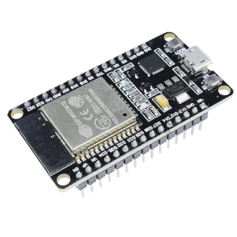

Fig1. ESP32

* + 1. 8-Channel Relay

The eight-channel relay module contains eight 5V relays and the associated switching and isolating components, which makes interfacing with a microcontroller or sensor easy with minimum components and connections. There are eight terminal blocks with six terminals each, and each block is shared by two relays. The terminals are screw type, which makes connections to mains wiring easy and changeable.

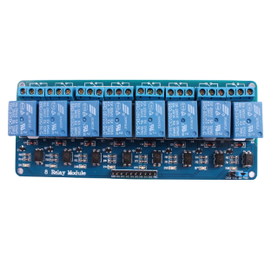

Fig2. 8-Channel Relay

* + 1. Bread Board

A breadboard is a solderless device for temporary prototype with electronics and test circuit designs. Most electronic components in electronic circuits can be interconnected by inserting their leads or terminals into the holes and then making connections through wires where appropriate. The breadboard has strips of metal underneath the board and connect the holes on the top of the board. The metal strips are laid out as shown below. Note that the top and bottom rows of holes are connected horizontally and split in the middle while the remaining holes are connected vertically.

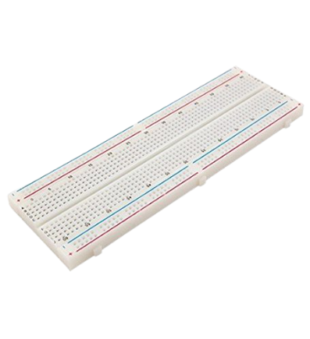

Fig3. Bread Board

* + 1. Jumper Wires

Jumper wires are simply wires that have connector pins at each end, allowing them to be used to connect two points to each other without soldering. Jumper wires are typically used with breadboards and other prototyping tools in order to make it easy to change a circuit as needed.

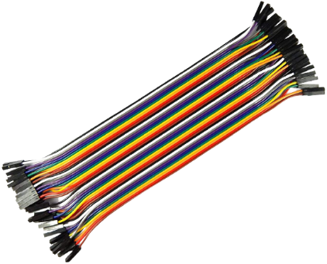

Fig4. Jumper Wires

* + 1. Regulator Switch

A switching regulator is a voltage regulator that uses a switching element to transform the incoming power supply into a pulsed voltage, which is then smoothed using capacitors, inductors, and other elements.

Power is supplied from the input to the output by turning ON a switch (MOSFET) until the desired voltage is reached.

Once the output voltage reaches the predetermined value the switch element is turned OFF and no input power is consumed.

Repeating this operation at high speeds makes it possible to supply voltage efficiently and with less heat generation.

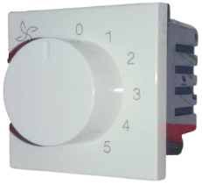

Fig5. Regulator Switch

* + 1. Prototype Board / Pref-Board

Perf-board is a material for prototyping electronic circuits (also called DOT PCB). It is a thin, rigid sheet with holes pre-drilled at standard intervals across a grid, usually a square grid of 0.1 inches (2.54 mm) spacing. These holes are ringed by round or square copper pads, though bare boards are also available. Inexpensive per board may have pads on only one side of the board, while better quality per board can have pads on both sides (plate-through holes). Since each pad is electrically isolated, the builder makes all connections with either wire wrap or miniature point to point wiring techniques. Discrete components are soldered to the prototype board such as resistors, capacitors, and integrated circuits. The substrate is typically made of paper laminated with phenolic resin (such as FR-2) or a fiberglass-reinforced epoxy laminate (FR-4).

Once the layout is finalized, the components are soldered in their designated locations, paying attention to orientation of polarized parts such as electrolytic capacitors, diodes, and integrated circuits. Next, electrical connections are made as called for in the layout.

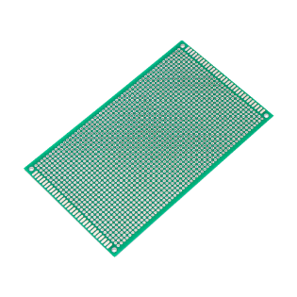

Fig6. Prototype Board

* + 1. Resistor

A passive electrical component with two terminals that are used for either limiting or regulating the flow of electric current in electrical circuits.

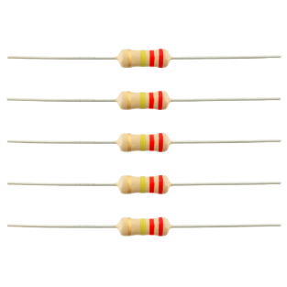

Fig7. Resistors

* + 1. Capacitor

A device used to store an electric charge, consisting of one or more pairs of conductors separated by an insulator.

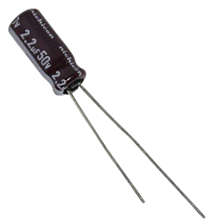

Fig8. Capacitor

* + 1. Light Bulb

A glass bulb or tube that produces light when it is supplied with electricity

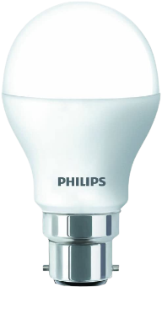

Fig9. Light Bulb

* 1. PROJECT REQUIREMENT
     1. Software Requirement
* Operating System: Windows 7,8,10.
* Front End: HTML, CSS, JavaScript.
* Back End: C, C++.
* Server management: Blynk.

1. Hyper Text Markup Language: (HTML)

Hypertext Markup Language (HTML) is the standard markup language for documents designed to be displayed in a web browser. It can be assisted by technologies such as Cascading Style Sheets (CSS) and scripting languages such as JavaScript. Web browsers receive HTML documents from a web server or from local storage and show the documents into multimedia web pages. HTML describes the structure of a web page semantically and originally included cues for the appearance of the document. HTML provides a means to create structured documents by denoting structural semantics for text such as headings, paragraphs, lists, links, quotes and other items. By this, with HTML you can create your own Website.

1. Cascading Style Sheet (CSS)

Cascading Style Sheets (CSS) is a style sheet language used for describing the presentation of a document written in a markup language like HTML. CSS is designed to enable the separation of presentation and content, including layout, colors, and fonts. This separation can improve content accessibility, provide more flexibility and control in the specification of presentation characteristics, enable multiple web pages to share formatting by specifying the relevant CSS in a separate .css file, and reduce complexity and repetition in the structural content. Separation of formatting and content also makes it feasible to present the same markup page in different styles for different rendering methods, such as on-screen, in print, by voice and on Braille-based tactile devices. CSS also has rules for alternate formatting if the content is accessed on a mobile device. The name cascading comes from the specified priority scheme to determine which style rule applies if more than one rule matches a particular element. This cascading priority scheme is predictable. In addition to HTML, other markup languages support the use of CSS including XHTML, plain XML

1. JavaScript: (JS)

JavaScript often abbreviated as JS, is an interpreted programming language. JavaScript is high-level, often just-in-time compiled, and multi-paradigm. It has curly- bracket syntax, dynamic typing, prototype-based object-orientation, and first-class functions. Alongside HTML and CSS, JavaScript is one of the core technologies of the World Wide Web. JavaScript enables interactive web pages and is an essential part of web applications. The vast majority of websites use it for client-side page behavior, and all major web browsers have a dedicated JavaScript engine to execute it. As a multi-paradigm language, JavaScript supports event-driven, functional, and imperative programming styles. Originally used only in web browsers, JavaScript engines are also now embedded in server-side website deployments and non-browser applications. Although there are similarities between JavaScript and Java, including language name, syntax, and respective standard libraries, the two languages are distinct and differ greatly in design.

1. C Language

C is a procedural programming language. It was initially developed by Dennis Ritchie as a system programming language to write operating system. The main features of C language include low-level access to memory, simple set of keywords, and clean style, these features make C language suitable for system programming like operating system or compiler development.

1. C++ Language

C++ is an advanced version of C procedural programming language.

* 1. ADVANTAGES

The In recent years, wireless systems like Wi-Fi have become more and more common in-home networking. Also, in home and building automation systems, the use of wireless technologies gives several advantages that could not be achieved using a wired network only.

1. Reduced installation costs: First and foremost, installation costs are significantly reduced since no cabling is necessary. Wired solutions require cabling, where material as well as the professional laying of cables (e.g., into walls) is expensive.
2. System scalability and easy extension: Deploying a wireless network is especially advantageous when, due to new or changed requirements, extension of the network is necessary. In contrast to wired installations, in which cabling extension is tedious. This makes wireless installations a seminal investment.
3. Aesthetical benefits: Apart from covering a larger area, this attribute helps to full aesthetical requirements as well. Examples include representative buddings with all-glass architecture and historical buddings where design or conservatory reasons do not allow laying of cables.
4. Integration of mobile devices: With wireless networks, associating mobile devices such as PDAs and Smartphones with the automation system becomes possible everywhere and at any time, as a device's exact physical location is no longer crucial for a connection (as long as the device is in reach of the network).

For all these reasons, wireless technology is not only an attractive choice in renovation and refurbishment, but also for new installations.

* 1. APPLICATIONS

Following are some applications of Home Automation System:

* Lighting control.
* HVAC Regulation: No Longer Burned by Your Heating Bill
* Smart home appliances.
* Improved home safety and security.
* Home air quality and water quality monitoring.
* Natural language-based voice assistants.

# CHAPTER 4

# SYSTEM ANALYSIS

Automation of a device has a wide scope for this Generation as well as in forthcoming generation. In this wide scope, Mobile communication technology is playing a major role in the world of automation. This article is fully based on low cost and reliable home control monitoring system for accessing and controlling devices and appliances remotely using Android based Smart phone application. While using this technology the system improves the living standard at home, reduces human effort, energy efficient and time saving and thus make a smart home .And also it was very helpful for providing support to disabled people and fulfil their needs in home and thus they leads a normal life. The proposed systems consist of android mobile, Arduino Uno board, Wi-Fi module and a relay circuit. We are using Wi-Fi technology to monitor the device because of its accuracy, high range and instant connectivity. This module controls the home appliances with a very ease of installation and it is user friendly.

Home Automation usually is comprised of three main parts:

* 1. Main Controller
  2. Interfaces
  3. Control methods

**4.1. MAIN AUTOMATION CONTROLLER:**

**4.1.1 ARDUINO UNO BOARD:**

The 8-bit AT mega 328P microcontroller based on Arduino UNO is used in this proposal is to control the different components like Wi-Fi module and relay circuit networks. The advantage to having a separate controller is to focus only on the desired task.

**4.2 INTERFACES:**

An Interface is the way we interact with the Home automation controller. There are many types of interfaces like Touch Panels, Keypads, Remotes, Mobile Devices and Internet.

In this proposal, we used a Mobile device (Android smart phone).Nowadays it is a very common device for every user. We need to install an appliance controller application in it. In addition, within the mobile interface it can be able to control all the respected appliances of the home.

**4.3 CONTROL METHODS:**

We now have a controller, interfaces to interact with the controller, and sensors that tell the controller what things are occurring in the house.

Controllers can communicate and control the many different parts of a Home Automation System in a variety of ways. Some of these are IP (Internet Protocol sp), Wi-Fi, Bluetooth, Zig-bee, IR, Serial Data, and Relays (for motorization).

**4.3.1 WI-FI TECHNOLOGY:**

Wi-Fi is a great option when you cannot get Ethernet wiring to desired locations. It is a good medium for communicating to different locations in the house, and will allow large bits of information to be passed back and forth with no wires. It is always best if we can get a wire to the location you are trying to control, but sometimes this is not possible or would be cost prohibitive.

*B. Advantage of using Wi-Fi technology:*

* Equipment can be placed almost anywhere

# No unsightly cords running through your home

* No need for additional Ethernet output

# Provide wide range and more efficient

**4.3 BLOCK DIAGRAM OF ARDUION UNO CONTROLLER**

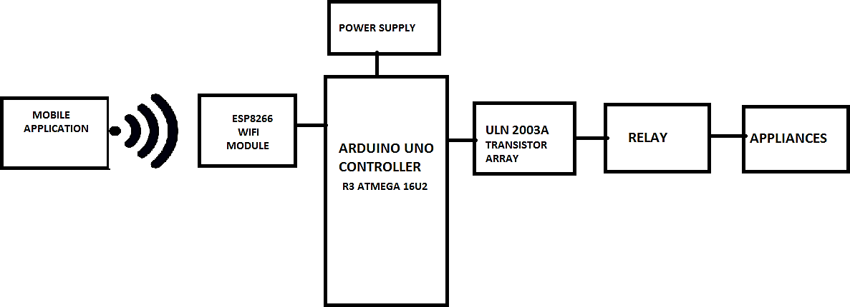

**Figure 4: Block diagram**

In this system, we are going to make a home automation system using ESP8266 Wi-Fi module and Arduino Uno Controller R3. With the help of these modules, we will be able to control lights, electric fan and other home appliances through a Wi-Fi application using our Android Smart phone. All the appliances will be connected to relays, which are controlled by the Arduino.

ESP8266 and Arduino together act as a web Server and it will send control commands through the mobile application i.e. android software.

We are implementing with the help of ESP8266 Wi-Fi Module, as it is a self- contained SoC with integration of TCP/IP stack, which may help any microcontroller having UART to access a Wi-Fi network. It can act as both Wi-Fi access point as well as a Wi-Fi client. It is pre-programmed with AT commands, so we can easily access and configure it using a microcontroller. First, we can connect ESP8266 with Arduino Uno. The ESP8266 runs on 3.3V, it may damage if you connect it directly to 5V from Arduino. Now we can connect relays to Arduino. Here a ULN IC is connected which is used as relay driver. Then all the AC devices are connected to relay output to ON/OFF the AC devices.

**A. ULN IC:**

It is a relay driver IC and it is a Darlington array having high voltages and high currents.

It is made up of seven open collector Darlington pairs having common emitter which show ULN2003 has a capability of handling seven different relays at a time.

A single Darlington pair consists of two bipolar transistors and operates in the range of 500mA and 600mA.

# CHAPTER 5

# REQUIREMENT ANALYSIS

**5.1 INTRODUCTION REQUIRMENT DESIGN**:

Introduces the systems development life cycle (SDLC), the fundamental four-phase model (planning, analysis, design, and implementation) common to all information systems development project It describes the evolution of system development methodologies and discusses the roles and skills required of a systems analyst. The chapter then overviews the basic characteristics of object-oriented systems and the fundamentals of object-oriented systems analysis and design and closes with a description of the Unified Process and its extensions and the Unified Modeling Language.

The main goal of systems analysis and design is to improve organizational systems, typically through applying software that can help employees accomplish key business tasks more easily and efficiently. As a systems analyst, you will be at the center of developing this software.

**5.1.1 CLASS DIAGRAM:**

The [class diagram](https://t4tutorials.com/class-diagram-and-domain-model-of-store-management-system-project/) is a model for creating the classes, their attributes, and functions. In [software engineering](http://en.wikipedia.org/wiki/Software_engineering), a class diagram in the [Unified Modelling Language](http://en.wikipedia.org/wiki/Unified_Modeling_Language) (UML) is a type of static structure diagram that describes the structure of a system by showing the system's [classes](http://en.wikipedia.org/wiki/Class_%28computer_science%29), their attributes, operations (or methods), and the relationships among objects. The class diagram is the main building block of [object oriented](http://en.wikipedia.org/wiki/Object_oriented) modelling. It is used both for general [conceptual modelling](http://en.wikipedia.org/wiki/Conceptual_model) of the systematic of the application, and for detailed modelling translating the models into [programming code](http://en.wikipedia.org/wiki/Programming_code). Class diagrams can also be used for [data modelling](http://en.wikipedia.org/wiki/Data_modeling). The classes in a class diagram represent both the main objects, interactions in the application and the classes to be programmed.

* **Purpose Of Class Diagram:**

In software engineering, a **class diagram** in the Unified Modelling Language (UML) is a type of static structure diagram that describes the structure of a system by showing the system's classes, their attributes, operations (or methods), and the relationships among objects.

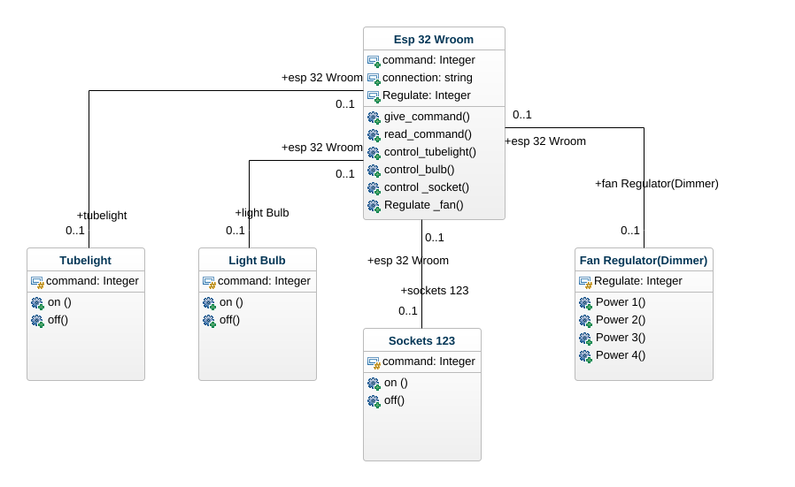

Fig 1 .Class Diagram for Home Automation System

In the above figure we have the class diagram which has controller, transceiver, light and fan. The controller has the attribute of alert_msg which is in the from string and command.It has functions to write_alert() messages to read_command() and to control appliances of fan and light control _fan(),control_light(). The tranceiver has alert_msg and command as attribute, If has function to receiver_command and send_alert. The light and fan has the status attribute which shows the status of appliances whether it is on or off .i.e. status: on,off and the function on() and off().

**5.1.2 DATA FLOW DIAGRAM:**

A data flow diagram (DFD) is a graphical representation of the "flow" of data through an [information system](http://en.wikipedia.org/wiki/Information_system), modelling its process aspects. Often they are a preliminary step used to create an overview of the system which can later be elaborated. DFDs can also be used for the [visualization](http://en.wikipedia.org/wiki/Data_visualization) of [data processing](http://en.wikipedia.org/wiki/Data_processing) (structured design). A DFD shows what kind of information will be input to and output from the system, where the data will come from and go to, and where the data will be stored. It does not show information about the timing of processes, or information about whether processes will operate in sequence or in parallel (which is shown on a [flowchart](http://en.wikipedia.org/wiki/Flowchart)).

A data flow diagram (DFD) is a graphical representation of the "flow" of data through an [information system](http://en.wikipedia.org/wiki/Information_system), modelling its process aspects. Often they are a preliminary step used to create an overview of the system which can later be elaborated. DFDs can also be used for the [visualization](http://en.wikipedia.org/wiki/Data_visualization) of [data processing](http://en.wikipedia.org/wiki/Data_processing) (structured design).

Data flow diagrams only involve four symbols. They are:

* Process
* Data Object
* Data Store
* External entity
* **Purpose OF Data Flow Diagram:**

Data flow diagrams provide a graphical representation of how information moves between processes in a system. Data flow diagrams follow a hierarchy; that is, a diagram may consist of several layers, each unique to specific process or data function.

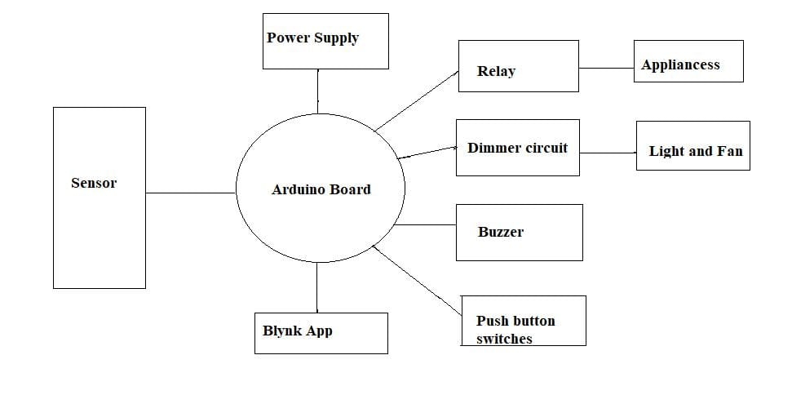 Fig 2. Data Flow Diagram for Home Automation System

The data flow diagram consist of sensor which given as input to Arduino Board .The Arduino board is connected to the power supply and blynk app it has relay, dimmer circuit has and buzzer connected to it. The relay is connected to all the appliances and the dimmer circuit has the light and fan appliances connected to it. The push button switches is also connected to the Arduino board which has esp-32 in it. The changes of Arduino reflect in the blynk app which is connected to the cloud interface.

**5.1.3 USE CASE DIAGRAM:**

A use case diagram at its simplest is a representation of a user's interaction with the system and depicting the specifications of a use case. A use case diagram can portray the different types of users of a system and the various ways that they interact with the system.

To model a system the most important aspect is to capture the dynamic behavior. To clarify a bit in details, dynamic behavior means the behavior of the system when it is running /operating. So only static behavior is not sufficient to model a system rather dynamic behavior is more important than static behavior. In UML there are five diagrams available to model dynamic nature and use case diagram is one of them. Now as we have to discuss that the use case diagram is dynamic in nature there should be some internal or external factors for making the interaction.

The purpose of use case diagram is to capture the dynamic aspect of a system. But this definition is too generic to describe the purpose. Because other four diagrams (activity, sequence, collaboration and State chart) are also having the same purpose. Use case diagrams are used to gather the requirements of a system including internal and external influences. These requirements are mostly design requirements.

* **Purpose Of Use Case Flow:**
* **Actors:** The users that interact with a system. An actor can be a person, an organization, or an outside system that interacts with your application or system. They must be external objects that produce or consume data.
* **System:** A specific sequence of actions and interactions between actors and the system. A system may also be referred to as a scenario.
* **Goals:** The end result of most use cases. A successful diagram should describe the activities and variants used to reach the goal.

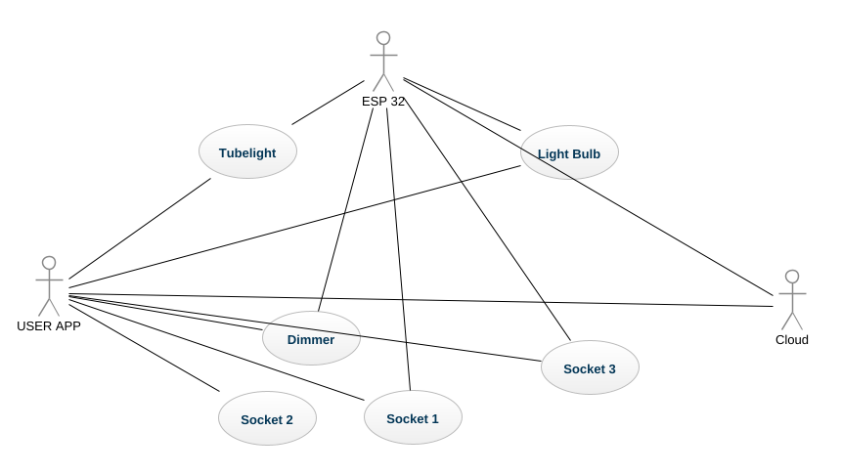

Fig 3. Use Case Diagram for Home Automation System

The above figure is a use case diagram of the web server based home automation system. It has the entity as user, sensor/actuator and cloud service database which is connected with the blynk app .The user can control all the appliances such as light, fan etc. The sensor has the control actuator read digital part and analog parts which includes read sensors in it .The cloud services includes all the request services of the appliances such as to control ac,fan and light . This all are connected with the blynk app and esp-32 node mcu which is connected.

**5.1.4 SEQUENCE DIAGRAM:**

Sequence diagrams, commonly used by developers, model the interactions between objects in a single use case. They illustrate how the different parts of a system interact with each other to carry out a function, and the order in which the interactions occur when a particular use case is executed.

They capture the interaction between objects in the context of a collaboration. **Sequence Diagrams** are time focus and they show the order of the interaction visually by using the vertical axis of the diagram.

A sequence diagram is structured in such a way that it represents a timeline which begins at the top and descends gradually to mark the sequence of interactions. Each object has a column and the messages exchanged between them are represented by arrows.

* **Purpose Of Sequence Diagram :**
* The sequence diagram is used primarily to show the interactions between objects in the sequential order that those interactions occur. Much like the class diagram, developers typically think sequence diagrams were meant exclusively for them.
* One of the primary uses of sequence diagrams is in the transition from requirements expressed as use cases to the next and more formal level of refinement. Use cases are often refined into one or more sequence diagrams.

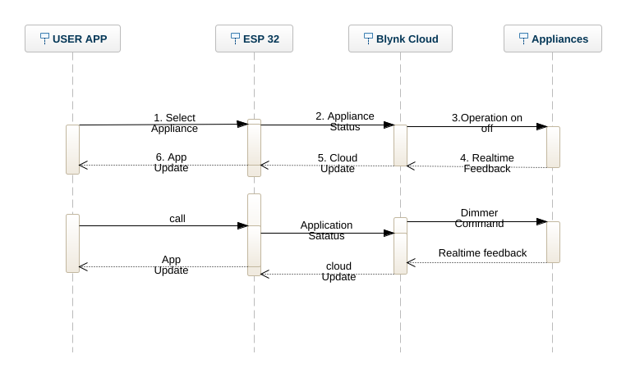

Fig 4.Sequence Diagram for Home Automation System

The above figure shows the sequence diagram of the home automation system .It has object as home owner controller and fan. The home owner can select the each object separately it select the fan then the status goes to the controller and it on the fan and also shows the status in the blynk app, then it can select turn on and turn off option with the specific set values such as 1 for off and 0 for on. When the user select the particular status ON or OFF the token get generated and the status in the app get updated as it is connected to the cloud through internet and appliances works accordingly. The acknowledgment for all the appliances get back to the controller i.e. esp-32 node mcu and it display the result on the home owner app.

**5.1.5 ACTIVITY DIAGRAM**

An activity diagram visually presents a series of actions or flow of control in a system similar to a flowchart or a data flow diagram. Activity diagrams are often used in business process modelling. They can also describe the steps in a use case diagram. Activities modelled can be sequential and concurrent. The [Unified Modeling Language](https://www.lucidchart.com/pages/what-is-UML-unified-modeling-language) includes several subsets of diagrams, including structure diagrams, interaction diagrams, and behavior diagrams.

Activity diagrams, along with [use case](https://www.lucidchart.com/pages/uml-use-case-diagram) and [state machine diagrams](https://www.lucidchart.com/pages/uml-state-machine-diagram), are considered behavior diagrams because they describe what must happen in the system being modeled. Activity diagrams help people on the business and development sides of an organization come together to understand the same process and behavior. You'll use a set of specialized symbols—including those used for starting, ending, merging, or receiving steps in the flow—to make an activity diagram, which we’ll cover in more depth within this activity diagram guide.

* **Purpose Of Activity Diagram :**
* Activity diagrams describe parallel and conditional activities, use cases and system functions at a detailed level. An activity diagram is used to model a large activity's sequential work flow by focusing on action sequences and respective action initiating conditions.
* An Activity Diagram is a behavioral diagram that shows the flow or sequence of activities through a system.  The terms activity diagram and process flow are often used interchangeably.  However, the term activity diagram is typically more restrictive as it refers to one of thirteen standard Unified Model Language (UML) diagrams.  Activity Diagrams are one of the most commonly used diagrams since its notation and origin are based on the widely known flowchart notation

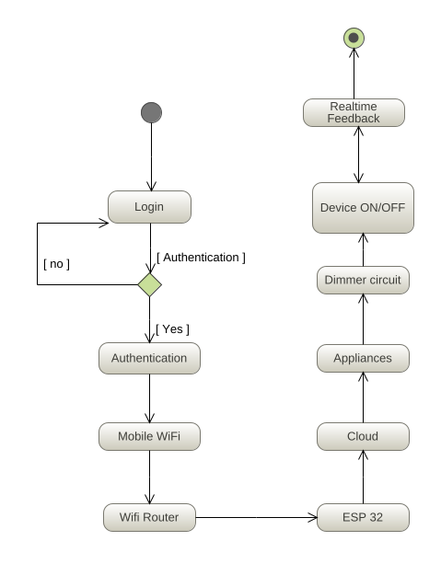

Fig 5.Activity Diagram for Home Automation System

5.1.6 DEPLOYMENT DIAGRAM:

A UML **deployment diagram** is a diagram that shows the configuration of run time processing nodes and the components that live on them. **Deployment diagrams** is a kind of structure diagram used in modelling the physical aspects of an object-oriented system. Deploymentdiagram is a UML diagram type that shows the execution architecture of a system, including nodes such as hardware or software execution environments, and the middleware connecting them. Deploymentdiagrams are typically used to visualize the physical hardware and software of a system.

Deployment diagram is a UML diagram type that shows the execution architecture of a system, including nodes such as hardware or software execution environments, and the middleware connecting them. Deployment diagrams are typically used to visualize the physical hardware and software of a system.

* **Purpose Of Deployment Diagram:**
* Deployment diagrams are used to visualize the topology of the physical components of a system, where the software components are deployed. Deployment diagrams are used to describe the static deployment view of a system. Deployment diagrams consist of nodes and their relationships.
* Deploymentdiagrams are mainly used by system engineers. These diagrams are used to describe the physical components (hardware), their distribution, and association

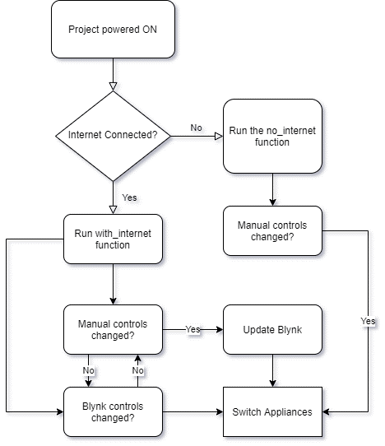

**Fig 6.Deployment Diagram for Home Automation System**

We have the Semantics Flowchart of Home Automation System in which we able to see first we give the power to the circuit then it checked whether it is connected to internet or not if it is connected to internet it run with the internet function and its code then it see whether we controlling manually or not by the app if controlling manually then Blynk controls will be changed it update the blynk app and appliances will be switch on.

If the internet is not connected then it run with the no internet function code and check whether the control changed manually or by app and then the appliances switch on.

**CHAPTER 6**

**SYSTEM DESIGN**

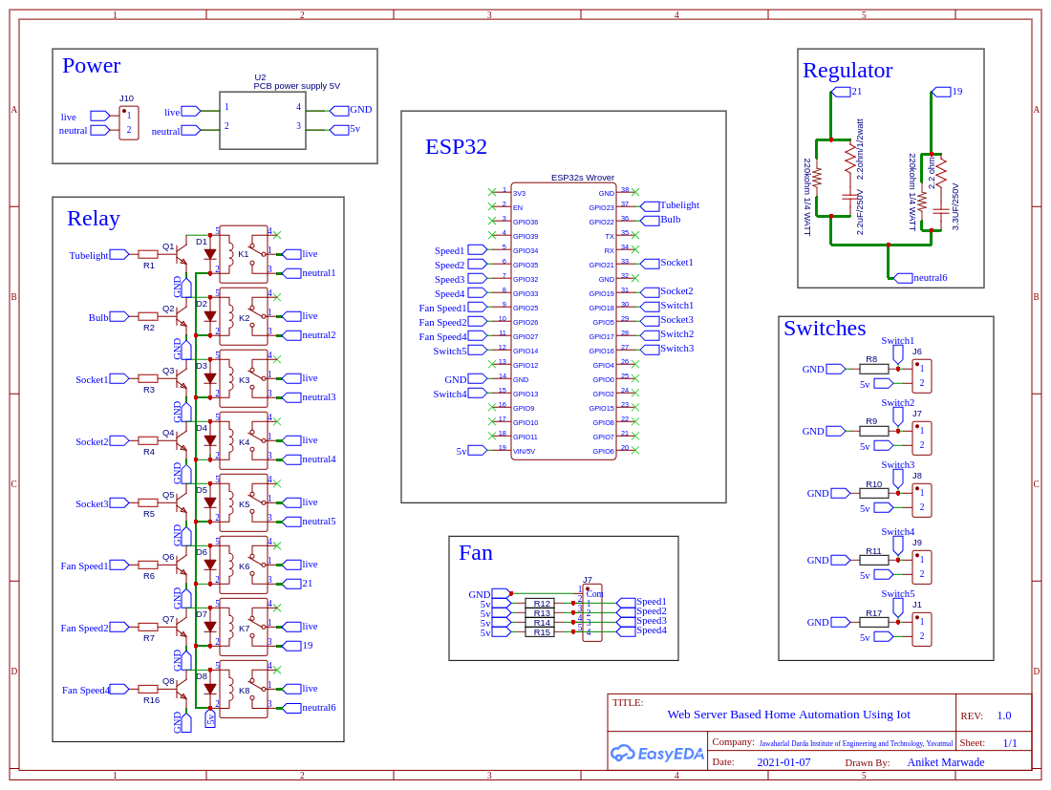**6.1 CIRCUIT DIAGRAM**

**Fig: Main Circuit Diagram**

**6.2 PIN DESCRIPTION**

ESP32-WROVER has in total 38 pins

|  |  |  |  |
| --- | --- | --- | --- |
| **Name** | **No.** | **Type** | **Function** |
| GND | 1 | P | Ground |
| 3V3 | 2 | P | Power supply |
| EN | 3 | I | Module-enable signal. Active high. |
| SENSOR_VP | 4 | I | GPIO36, ADC1_CH0, RTC_GPIO0 |
| SENSOR_VN | 5 | I | GPIO39, ADC1_CH3, RTC_GPIO3 |
| IO34 | 6 | I | GPIO34, ADC1_CH6, RTC_GPIO4 |
| IO35 | 7 | I | GPIO35, ADC1_CH7, RTC_GPIO5 |
| IO32 | 8 | I/O | GPIO32, XTAL_32K_P (32.768 kHz crystal oscillator input), ADC1_CH4,  TOUCH9, RTC_GPIO9 |
| IO33 | 9 | I/O | GPIO33, XTAL_32K_N (32.768 kHz crystal oscillator output),  ADC1_CH5, TOUCH8, RTC_GPIO8 |
| IO25 | 10 | I/O | GPIO25, DAC_1, ADC2_CH8, RTC_GPIO6, EMAC_RXD0 |
| IO26 | 11 | I/O | GPIO26, DAC_2, ADC2_CH9, RTC_GPIO7, EMAC_RXD1 |
| IO27 | 12 | I/O | GPIO27, ADC2_CH7, TOUCH7, RTC_GPIO17, EMAC_RX_DV |
| IO14 | 13 | I/O | GPIO14, ADC2_CH6, TOUCH6, RTC_GPIO16, MTMS, HSPICLK,  HS2_CLK, SD_CLK, EMAC_TXD2 |
| IO12 1 | 14 | I/O | GPIO12, ADC2_CH5, TOUCH5, RTC_GPIO15, MTDI, HSPIQ,  HS2_DATA2, SD_DATA2, EMAC_TXD3 |
| GND | 15 | P | Ground |
| IO13 | 16 | I/O | GPIO13, ADC2_CH4, TOUCH4, RTC_GPIO14, MTCK, HSPID,  HS2_DATA3, SD_DATA3, EMAC_RX_ER |
| SHD/SD2 2 | 17 | I/O | GPIO9, SD_DATA2, SPIHD, HS1_DATA2, U1RXD |
| SWP/SD3 2 | 18 | I/O | GPIO10, SD_DATA3, SPIWP, HS1_DATA3, U1TXD |
| SCS/CMD 2 | 19 | I/O | GPIO11, SD_CMD, SPICS0, HS1_CMD, U1RTS |
| SCK/CLK 2 | 20 | I/O | GPIO6, SD_CLK, SPICLK, HS1_CLK, U1CTS |
| SDO/SD0 2 | 21 | I/O | GPIO7, SD_DATA0, SPIQ, HS1_DATA0, U2RTS |
| SDI/SD1 2 | 22 | I/O | GPIO8, SD_DATA1, SPID, HS1_DATA1, U2CTS |
| IO15 | 23 | I/O | GPIO15, ADC2_CH3, TOUCH3, MTDO, HSPICS0, RTC_GPIO13,  HS2_CMD, SD_CMD, EMAC_RXD3 |
| IO2 | 24 | I/O | GPIO2, ADC2_CH2, TOUCH2, RTC_GPIO12, HSPIWP, HS2_DATA0,  SD_DATA0 |
| IO0 | 25 | I/O | GPIO0, ADC2_CH1, TOUCH1, RTC_GPIO11, CLK_OUT1,  EMAC_TX_CLK |
| IO4 | 26 | I/O | GPIO4, ADC2_CH0, TOUCH0, RTC_GPIO10, HSPIHD, HS2_DATA1,  SD_DATA1, EMAC_TX_ER |
| NC1 | 27 | - | - |
| NC2 | 28 | - | - |
| IO5 | 29 | I/O | GPIO5, VSPICS0, HS1_DATA6, EMAC_RX_CLK |
| IO18 | 30 | I/O | GPIO18, VSPICLK, HS1_DATA7 |

|  |  |  |  |
| --- | --- | --- | --- |
| Name | No. | Type | Function |
| IO19 | 31 | I/O | GPIO19, VSPIQ, U0CTS, EMAC_TXD0 |
| NC | 32 | - | - |
| IO21 | 33 | I/O | GPIO21, VSPIHD, EMAC_TX_EN |
| RXD0 | 34 | I/O | GPIO3, U0RXD, CLK_OUT2 |
| TXD0 | 35 | I/O | GPIO1, U0TXD, CLK_OUT3, EMAC_RXD2 |
| IO22 | 36 | I/O | GPIO22, VSPIWP, U0RTS, EMAC_TXD1 |
| IO23 | 37 | I/O | GPIO23, VSPID, HS1_STROBE |
| GND | 38 | P | Ground |

**Table 1: Pin Definitions**

1. GPIO12 is internally pulled high in the module and is not recommended for use as a touch pin.
2. Pins SCK/CLK, SDO/SD0, SDI/SD1, SHD/SD2, SWP/SD3 and SCS/CMD, namely, GPIO6 to GPIO11 are connected to the SPI flash integrated on the module and are not recommended for other uses.

**6.3 PIN DESCRIPTION**

ESP32 has five strapping pins, which can be seen in Chapter 6 Schematics:

* + 1. MTDI
    2. GPIO0
    3. GPIO2
    4. MTDO
    5. GPIO5

Software can read the values of these five bits from register”GPIO_STRAPPING”. During the chip’s system reset release (power-on-reset, RTC watchdog reset and brownout reset), the latches of the strapping pins sample the voltage level as strapping bits of ”0” or ”1”, and hold these bits until the chip is powered down or shut down. The strapping bits configure the device’s boot mode, the operating voltage of VDD_SDIO and other initial system settings.

Each strapping pin is connected to its internal pull-up/pull-down during the chip reset. Consequently, if a strapping pin is unconnected or the connected external circuit is high-impedance, the internal weak Pull p up/pull-down will determine the default input level of the strapping pins.

To change the strapping bit values, users can apply the external pull-down/pull-up resistances, or use the host MCU’s GPIOs to control the voltage level of these pins when powering on ESP32.

|  |  |  |  |
| --- | --- | --- | --- |
| **Voltage of Internal LDO (VDD_SDIO)** | | | |
| **Pin** | **Default** | **3.3 V** | **1.8 V** |

|  |  |  |  |  |  |
| --- | --- | --- | --- | --- | --- |
| MTDI | Pull-down | 0 | | 1 | |
| Booting Mode | | | | | |
| Pin | Default | SPI Boot | | Download Boot | |
| GPIO0 | Pull-up | 1 | | 0 | |
| GPIO2 | Pull-down | Don’t-care | | 0 | |
| Enabling/Disabling Debugging Log Print over U0TXD During Booting | | | | | |
| Pin | Default | U0TXD Active | | U0TXD Silent | |
| MTDO | Pull-up | 1 | | 0 | |
| Timing of SDIO Slave | | | | | |
| Pin | Default | FE Sampling  FE Output | FE Sampling  RE Output | RE Sampling  FE Output | RE Sampling  RE Output |
| MTDO | Pull-up | 0 | 0 | 1 | 1 |
| GPIO5 | Pull-up | 0 | 1 | 0 | 1 |

**Table 2: Strapping Pins**

* Firmware can configure register bits to change the settings of “Voltage of Internal LDO (VDD_SDIO)” and “Timing of SDIO Slave” after booting.
* The MTDI is internally pulled high in the module, as the flash and SRAM in ESP32-WROVER only support a power voltage of 1.8 V (output by VDD_SDIO).

**6.4 FLOW CHART**

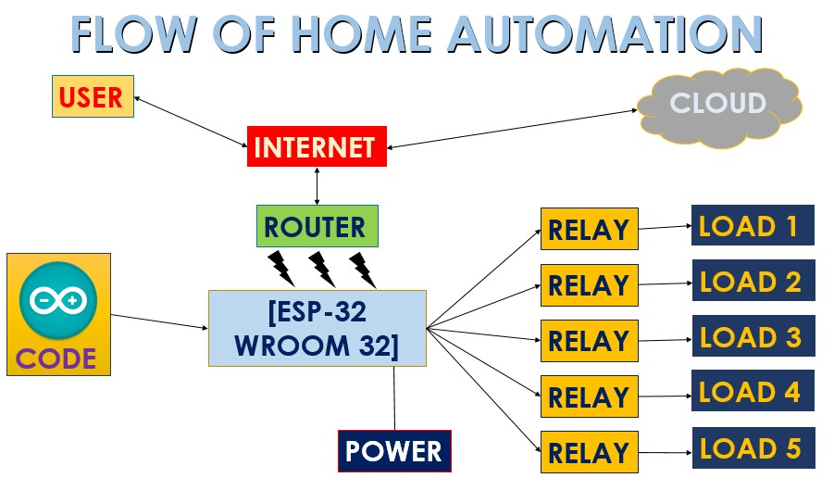

**Figure 2: Flow Chart of Home Automation System**

Above figure shows the flow chart of Home Automation System in which we have the various components such as User, Cloud, Esp-32 Wroom 32, Relay, Router and Load.

The user is connected to the internet which it is connected to router and the cloud of the blink app server, the app gets activated when it is connected to the internet then it gets updated form the cloud platform. The user do the changes it switch ON the fan, light and OFF it, it reflect in the app the router provides the internet connection to the circuit. The ESP 32 can perform a complete standalone system or as a slave device to the Host MCU, reducing communication stack overhead on the main application process, it is connected to the power and with all relays.

The ESP32 is coded in the C++ language, it generates the token and provide to blink app, the load 1, 2, 3, 4 can have various appliances connected to it.

We have the Semantics Flowchart of Home Automation System in which we able to see first we give the power to the circuit then it checked whether it is connected to internet or not if it is connected to internet it run with the internet function and its code then it see whether we controlling manually or not by the app if controlling manually then Blynk controls will be changed it update the blynk app and appliances will be switch on.

If the internet is not connected then it run with the no internet function code and check whether the control changed manually or by app and then the appliances switch on.

**CHAPTER 7**

**IMPLEMENTATION**

Implementation is the stage of the project when the theoretical design is turned out into a working system. Thus, it can be considered to be the most critical stage in achieving a successful new system and in giving the user, confidence that the new system will work and be effective. The implementation stage involves careful planning, investigation of the existing system and its constraints on implementation, designing of methods to achieve changeover and evaluation of changeover methods.

There are 5 main modules of this project:-

* With Internet Function
* Real-time Feedback
* Without Internet Function
* Application Module(Includes Cloud)
* Voice Assistant Module

**7.1 WITH INTERNET FUNCTION**

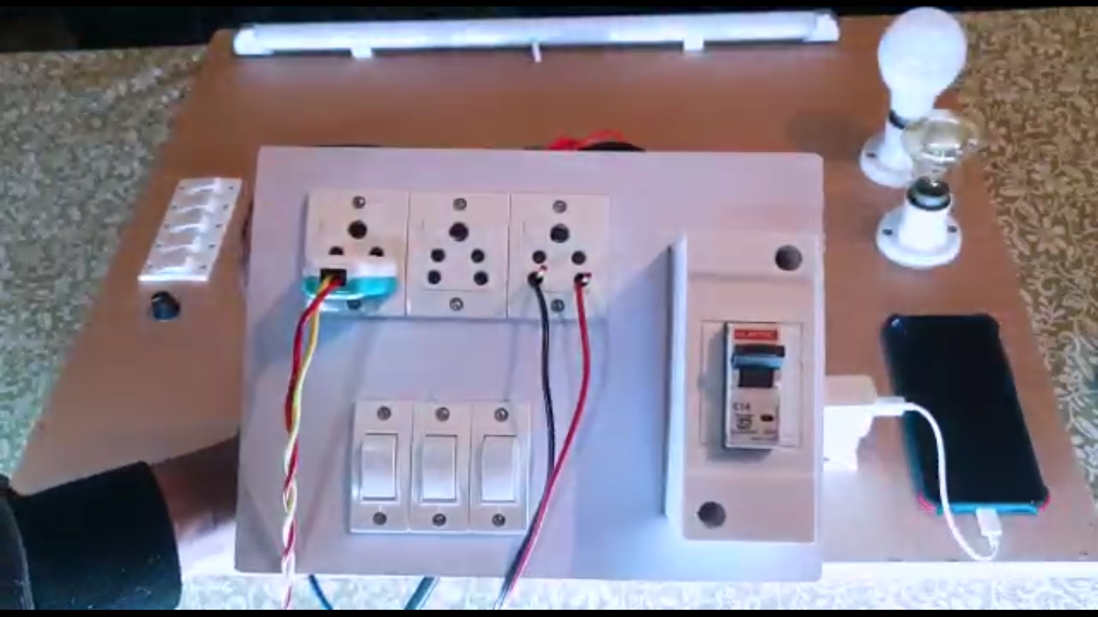

**Fig7.1.1: Switching the main circuit on.**

Now since we switched on the main circuit and switched on the Wi-Fi router the project microcontroller i.e. ESP32 will connect to the internet and cloud connection will establish. After establishing the connection the with internet function will execute and following process will begin:-

**(A)** **Switching on tube light [LOAD 1]**

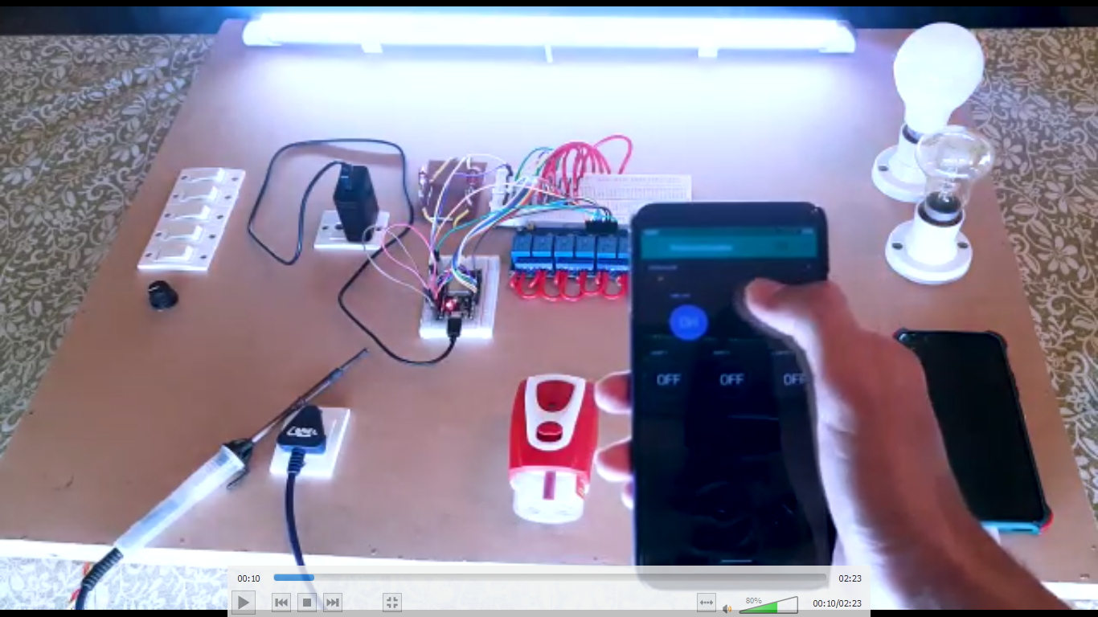

**Fig7.1.1: Switching the tube light on.**

The Blynk app is used to switch on the tube light and at the same time it is connected to the cloud so it switch ons the Tube light after user clicks on tube light switch. Here the relay number 1 is in use.

**(B)** **Switching on light bulb [LOAD 2]**

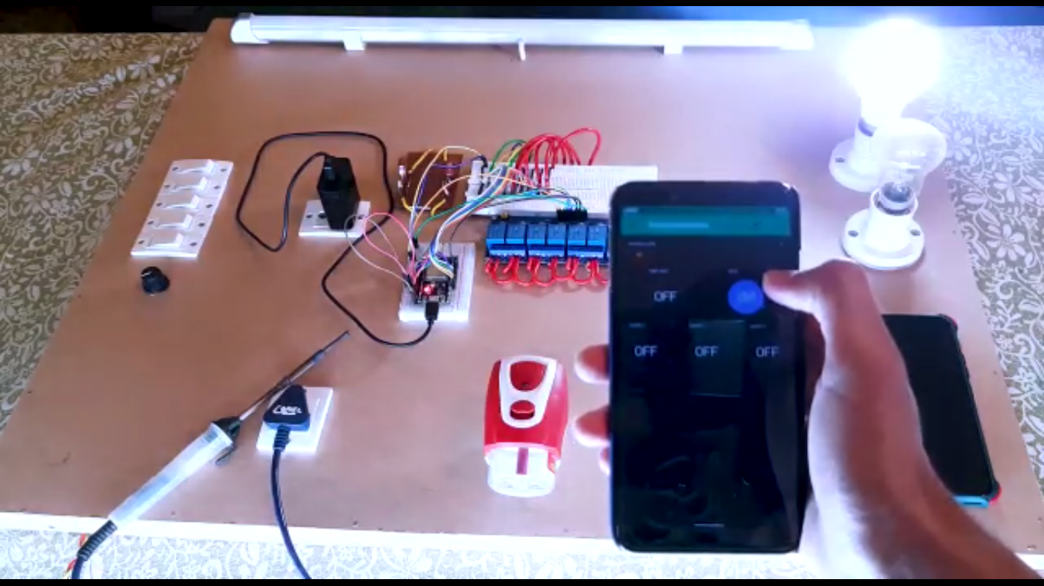

**Fig7.1.2: Switching the light bulb on.**

The Blynk app is used to switch on the light bulb and at the same time it is connected to the cloud so it switch ons the light bulb after user clicks on light bulb switch. Here relay no 2 is in use.

**(C)** **Switching on Socket 1 [LOAD 3]**

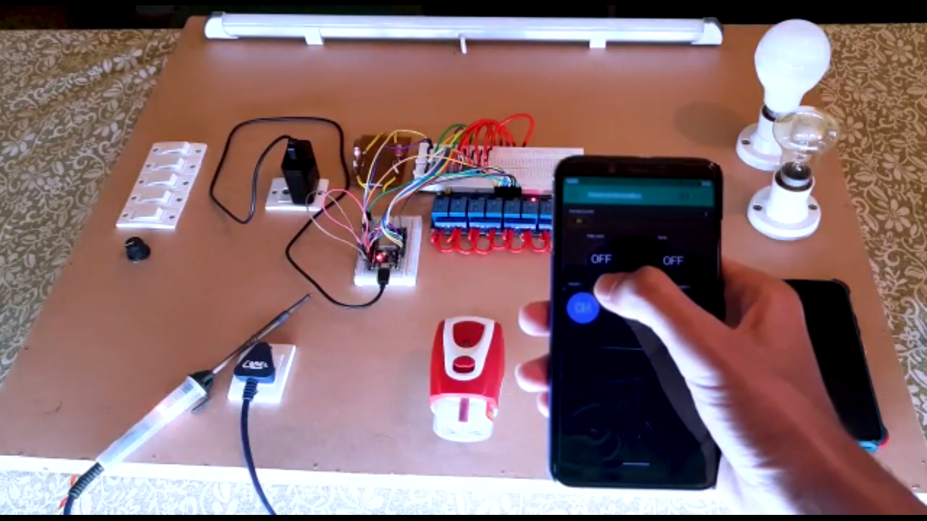

**Fig7.1.3: Switching the Socket 1 on.**

The Blynk app is used to switch on the Socket 1and at the same time it is connected to the cloud so it switch ons the Socket 1after user clicks on Socket 1switch. Here relay no 3 is in use.

**(D)** **Switching on Socket 2 [LOAD 4]**

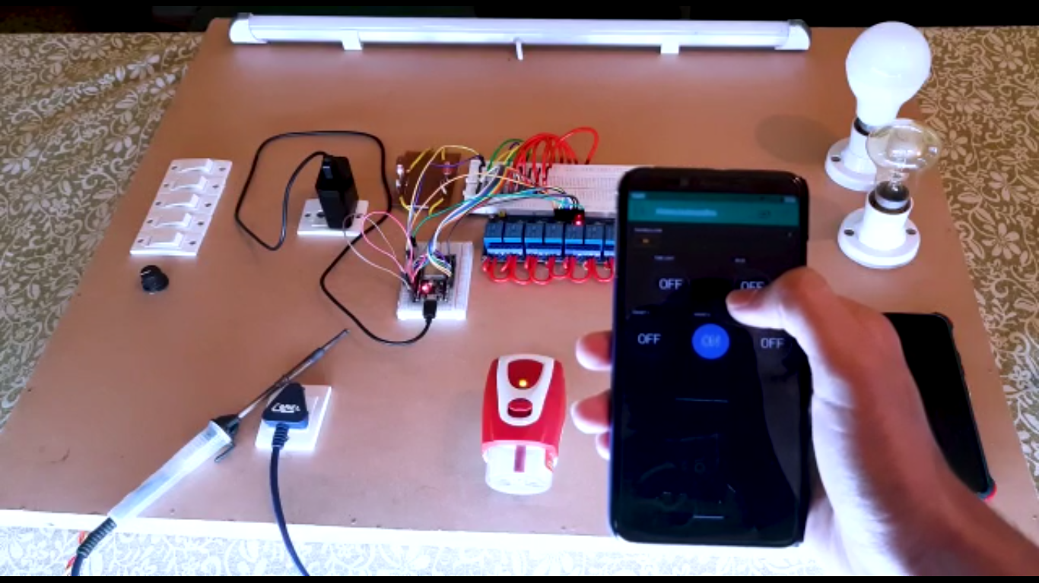

**Fig7.1.4: Switching the Socket 2 on.**

The Blynk app is used to switch on the Socket 2 and at the same time it is connected to the cloud so it switch ons the Socket 2 after user clicks on socket 2 switch. Here relay no 4 is in use.

**(E)** **Switching on Socket 3 [LOAD 5]**

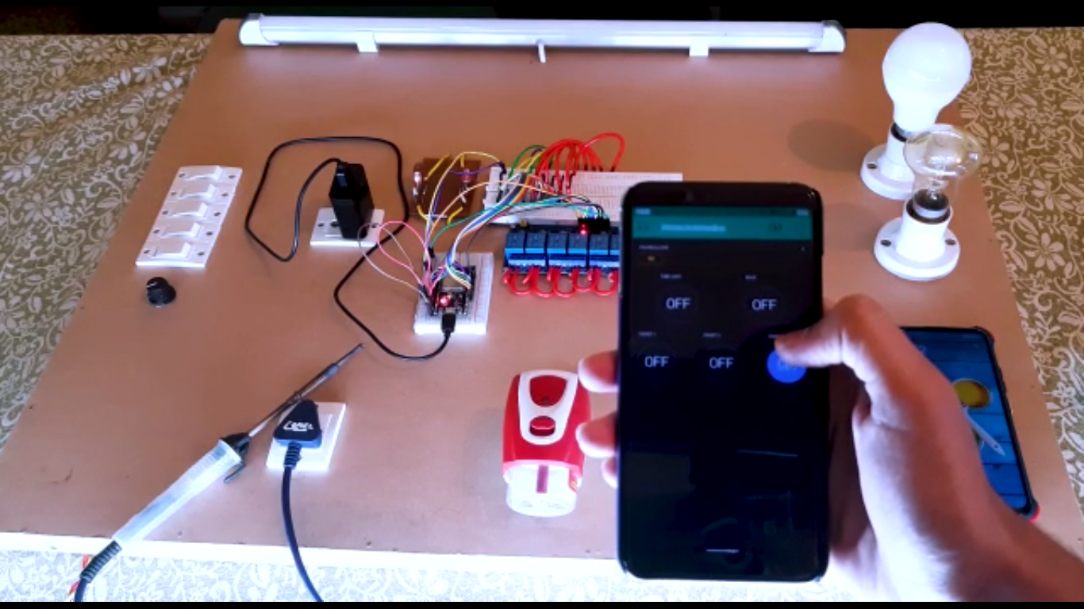

**Fig7.1.5: Switching the Socket 3 on.**

The Blynk app is used to switch on the Socket 3 and at the same time it is connected to the cloud so it switch ons the Socket 3 after user clicks on Socket 3 switch. Here relay no 5 is in use.

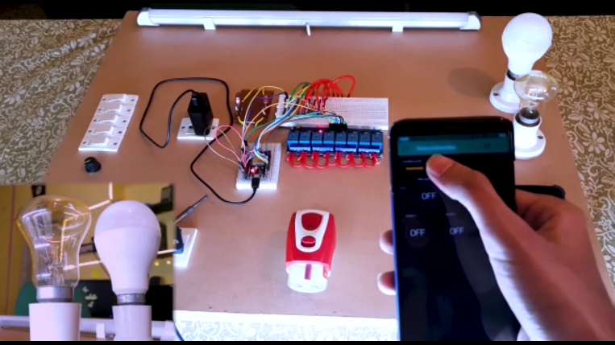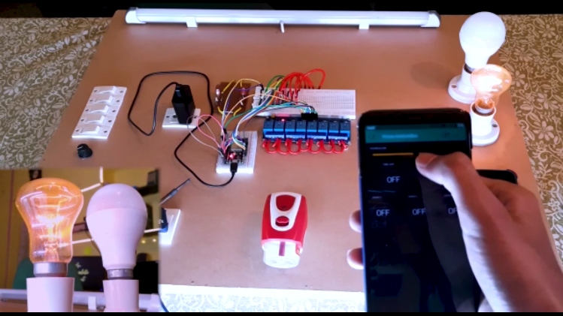**(E)** **Controlling Dimmer [LOAD 6]**

**Fig 7.1.6 Power 1 on Dimmer Fig 7.1.7 Power 2 on Dimmer**

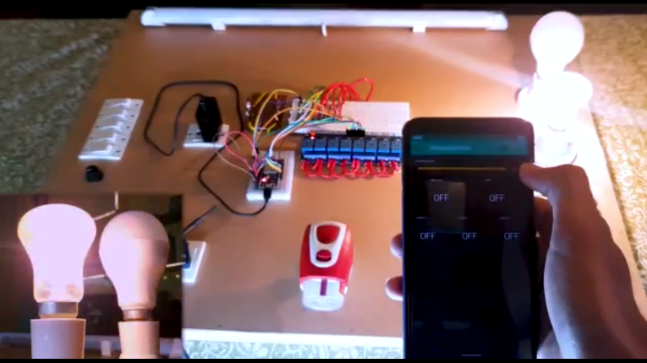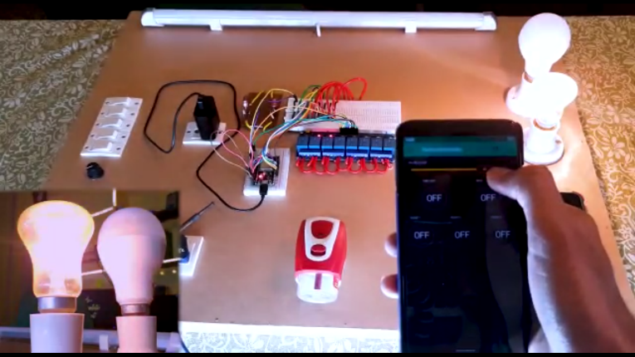

**Fig 7.1.8 Power 3 on Dimmer Fig 7.1.9 Power 4 on Dimmer**

The Blynk app is used to switch on and control the Dimmer and at the same time it is connected to the cloud so it switch ons the Dimmer circuit after user clicks on Fan Regulator dragger. Here relay no 6 is used for dimmer at power 1 with minimum electricity to be passed, relay 7 is used for dimmer at power 2, relay 8 is used for dimmer at power 3 and at last full 220 volt is passed without any relay to the fan i.e. 100 watt bulb that we have used in project instead of fan with maximum electricity to be passed.

**7.2 REALTIME FEEDBACK**

The Project when connected to internet gets connected to cloud called blynk cloud, hence every command that is given to the microcontroller goes through the blynk cloud therefore it the project is operated manually, the cloud also gets updated and since the cloud and blynk app are connected it gives real-time feedback to the application. These are the implementation of the real-time feedback module of the project:

**(A) Switching on Tube light manually and getting Real-time Feedback**

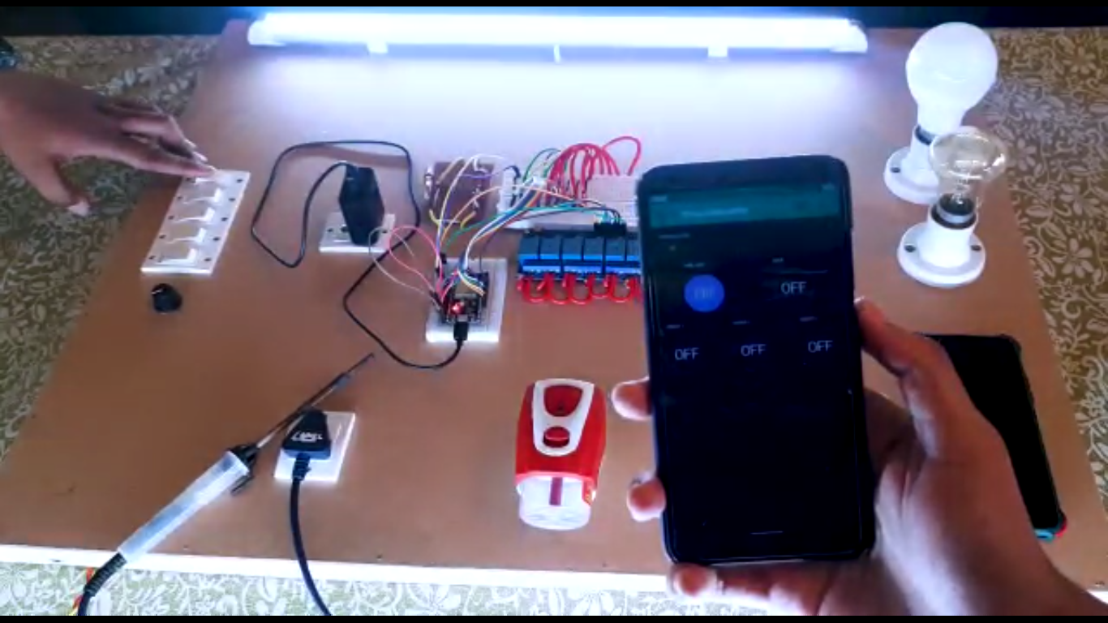

**Fig7.2.1: Switching on Tube light manually and getting Real-time Feedback**

While the project microcontroller is connected to the internet and if operated manually we can see when the Tube light is switched on manually the switch on the blynk app for tube light gets updated automatically this feature is called real-time feedback.

**(B) Switching on Light Bulb manually and getting Real-time Feedback**

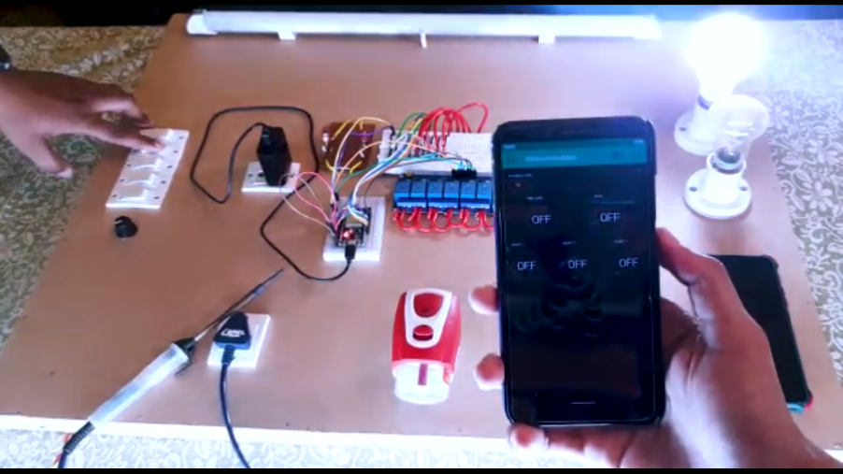

**Fig7.2.2: Switching on Light Bulb manually and getting Real-time Feedback**

The same type of manual switch is given to the light bulb, so when it is switched on the cloud value for the light bulb gets updated and it updates the switch in the Blynk app and turns it on.

**(C) Switching on Socket 1 manually and getting Real-time Feedback**

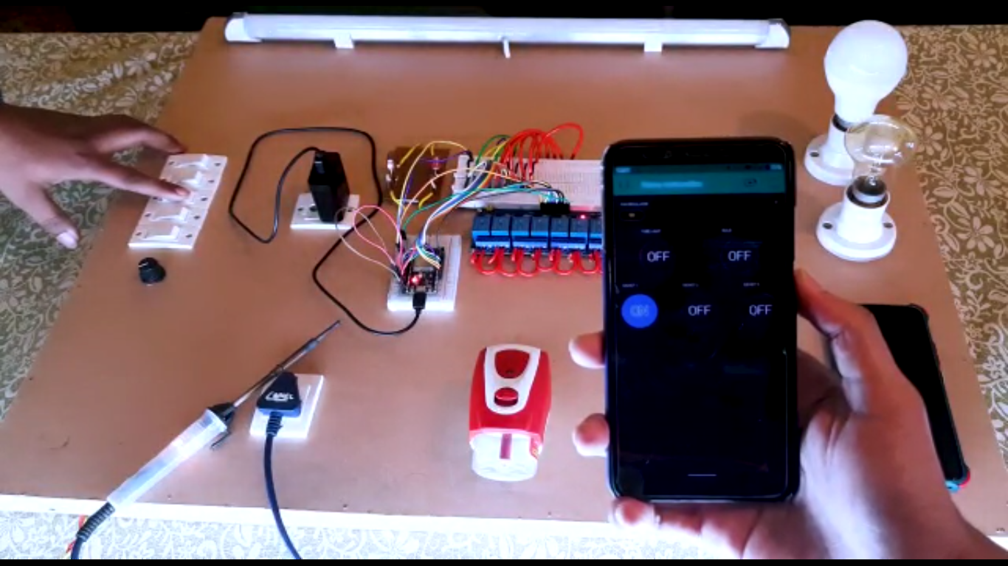

**Fig7.2.3: Switching on Socket 1 manually and getting Real-time Feedback**

Somewhere the same type of functionality is also given to the sockets as it is also operated using one relay, so when the manual switch is switched on the cloud gets updated and at the same time the switch assigned to Socket 1 is also switched on and gives real time feedback.

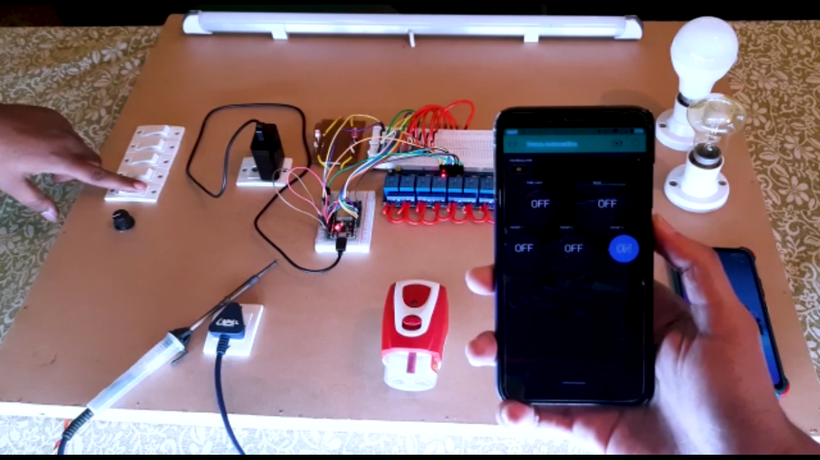**(D) Switching on Socket 3 manually and getting Real-time Feedback**

**Fig7.2.4: Switching on Socket 3 manually and getting Real-time Feedback**

Somewhere the same type of functionality is also given to the sockets as it is also operated using one relay, so when the manual switch is switched on the cloud gets updated and at the same time the switch assigned to Socket 3 is also switched on and gives real time feedback.

**(E) Regulating Dimmer manually and Getting Real time Feedback**

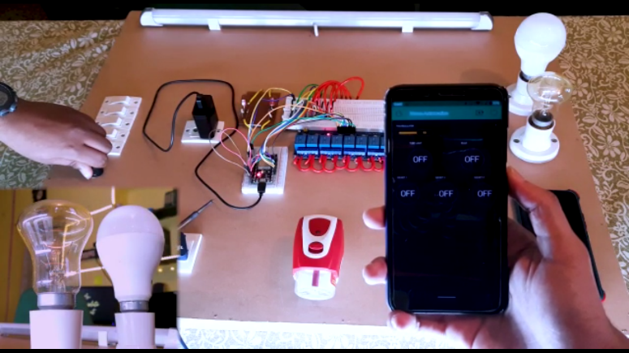

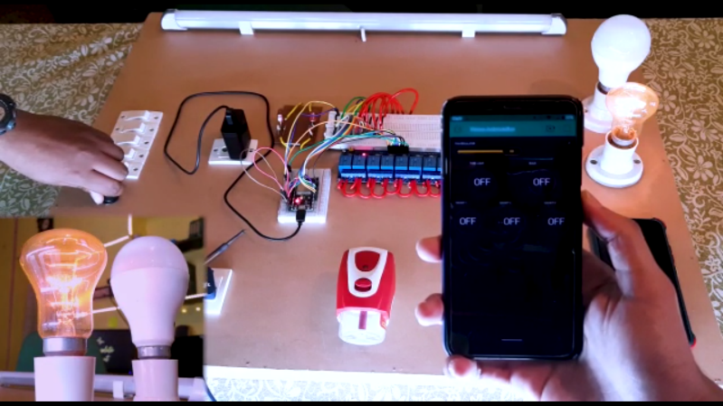

**Fig 7.2.5 Power 1 on manual Dimmer with RTF Fig 7.2.6 Power 2 manual Dimmer with RTF**

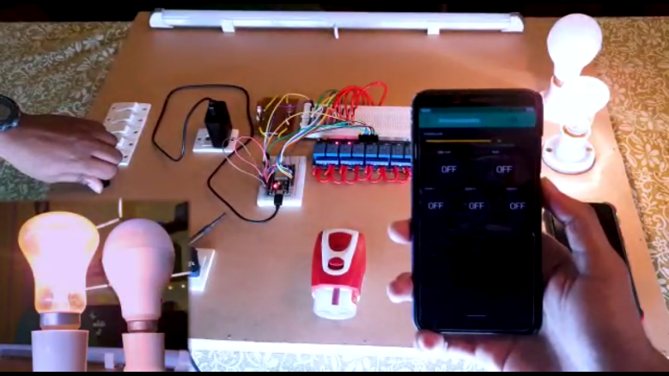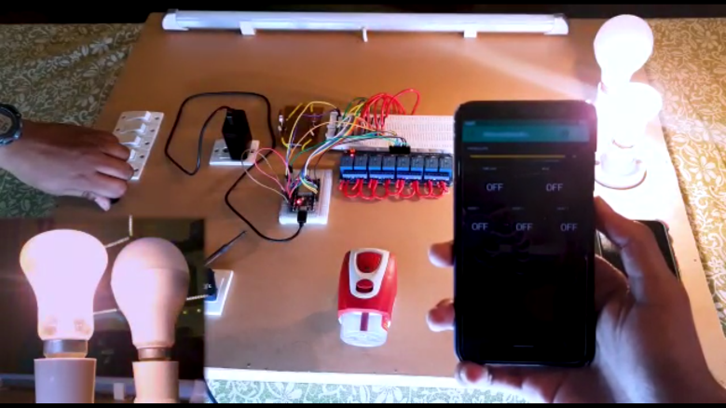

**Fig 7.2.7 Power 3 on manual Dimmer with RTF Fig 7.2.8 Power 4 manual Dimmer with RTF**

In the project there is manual knob called as fan regulator is attached which controls dimmer manually and as the project microcontroller i.e. NODE MCU ESP 32 Wroom, is connected to the internet and cloud so as the knob is rotated in clockwise direction the dimmer starts getting power in ascending order and at the same time the cloud is also getting updated and showing real time feedback to the Blynk Application, as we can see in the given figures above.

**7.3 WITHOUT INTERNET FUNCTION**

The Project also has one feature which allows itself to operate when the internet to the ESP 32 Wroom is disconnected and there is no connectivity y to the cloud. Here the Appliances attached to the prototype board operated as a manual electricity board present at our house walls. It has electrical connections done so that it can be operated when there is no internet. The following figures shows the operations perfectly:-

**(A) Switching on Tube light without internet**

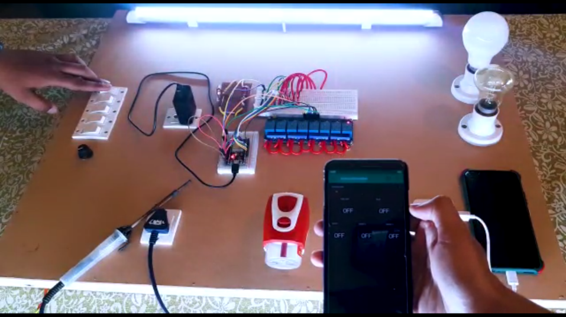

**Fig7.3.1: Switching on Tube light without internet**

When the tube light switch on prototype board is turned on the microcontroller checks weather the project is connected to the internet by using check internet function it checks internet and gets response that there is no internet and doesn’t updates the app switch as shown in the figure above.

**(B) Switching on Light bulb without internet**

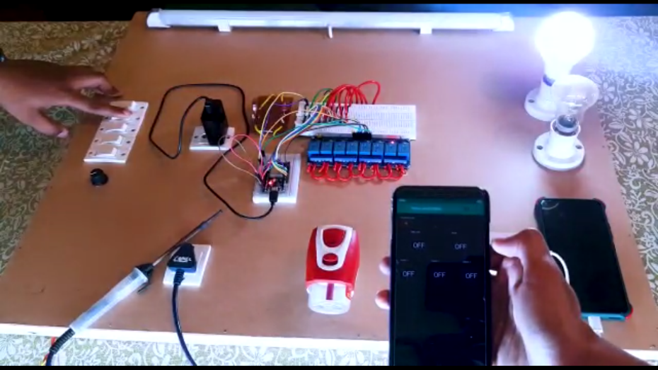

**Fig7.3.2: Switching on Light bulb without internet**

Here the light bulb switch on prototype board is turned on the microcontroller checks weather the project is connected to the internet by using check internet function it checks internet and gets response that there is no internet and doesn’t updates the app switch as shown in the figure above.

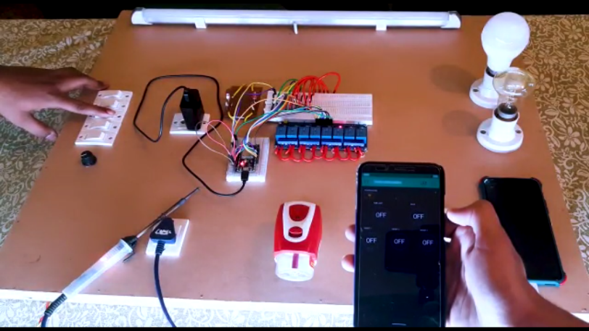**(B) Switching on Sockets 1 2 3 without internet**

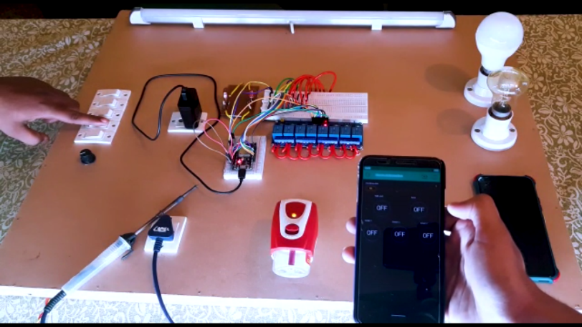

**Fig 7.3.3 Switching on Sockets 1 without internet Fig 7.3.4 Switching on Sockets 2 without internet**

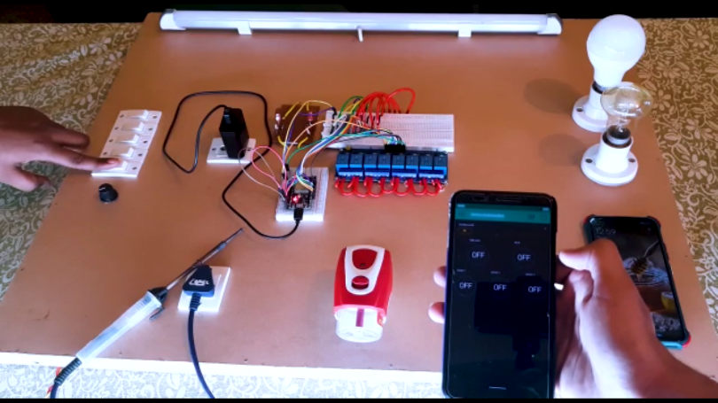

**Fig7.3.5. Switching on Sockets 3 without internet**

Here the Sockets 1 2 & 3 switch on prototype board is turned on the microcontroller checks weather the project is connected to the internet by using check internet function it checks internet and gets response that there is no internet and doesn’t updates the app switch as shown in the figure above.

**7.4 APPLICATION MODULE**

Blynk was designed for the Internet of Things. It can control hardware remotely, it can display sensor data, and it can store data, visualize it and do many other cool things.

There are three major components in the platform:

**Blynk App** - allows to you create amazing interfaces for your projects using various widgets we provide.

**Blynk Server** - responsible for all the communications between the smartphone and hardware. You can use our Blynk Cloud or run your private Blynk server locally. Its open-source, could easily handle thousands of devices and can even be launched on a Raspberry Pi.

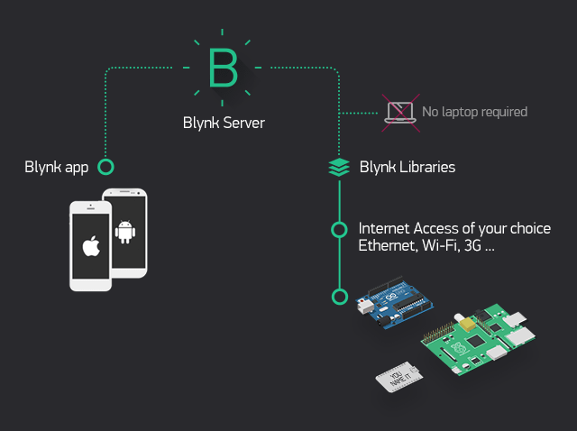**Blynk Libraries** - for all the popular hardware platforms - enable communication with the server and process all the incoming and out coming commands.

**Fig7.4.1. Switching on Sockets 3 without internet**

Now imagine: every time you press a Button in the Blynk app, the message travels to space the Blynk Cloud, where it magically finds its way to your hardware. It works the same in the opposite direction and everything happens in a blynk of an eye.

The application module is mainly divided into 6 steps the steps for getting started with the blynk app are as follows:

1**.** Create a Blynk Account

2. Create a new Project

3. Choose Your Hardware

4. Auth Token Setting

5. Add a Widget

6. Run the Project

**7.4.1. Create a Blynk Account {STEP 1}**

After you download the Blynk App, you’ll need to create a New Blynk account. This account is separate from the accounts used for the Blynk Forums, in case you already have one.

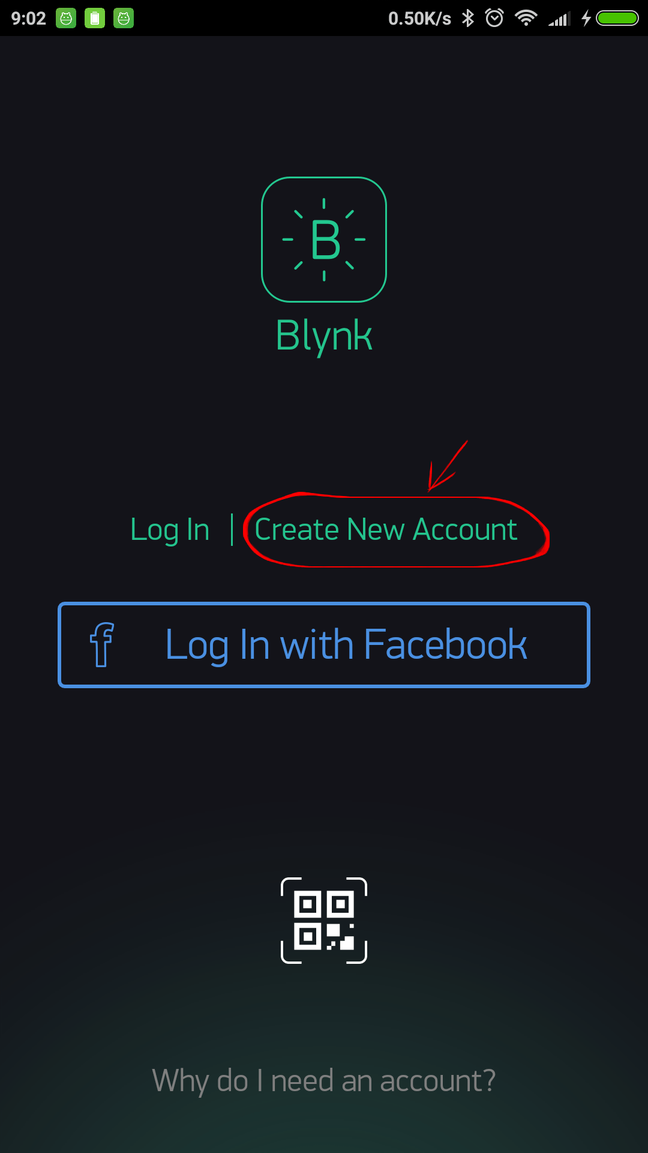

**Fig: 7.4.1. Create a Blynk Account**

An account is needed to save your projects and have access to them from multiple devices from anywhere. It’s also a security measure. After you successful create an account, start by creating a new project.

**7.4.2. Create a new Project {STEP 2}**

After you’ve successfully logged into your account, start by creating a new project. Create a project name and choose device by ESP32 Dev Board and choose connection type by Wi-Fi.

.

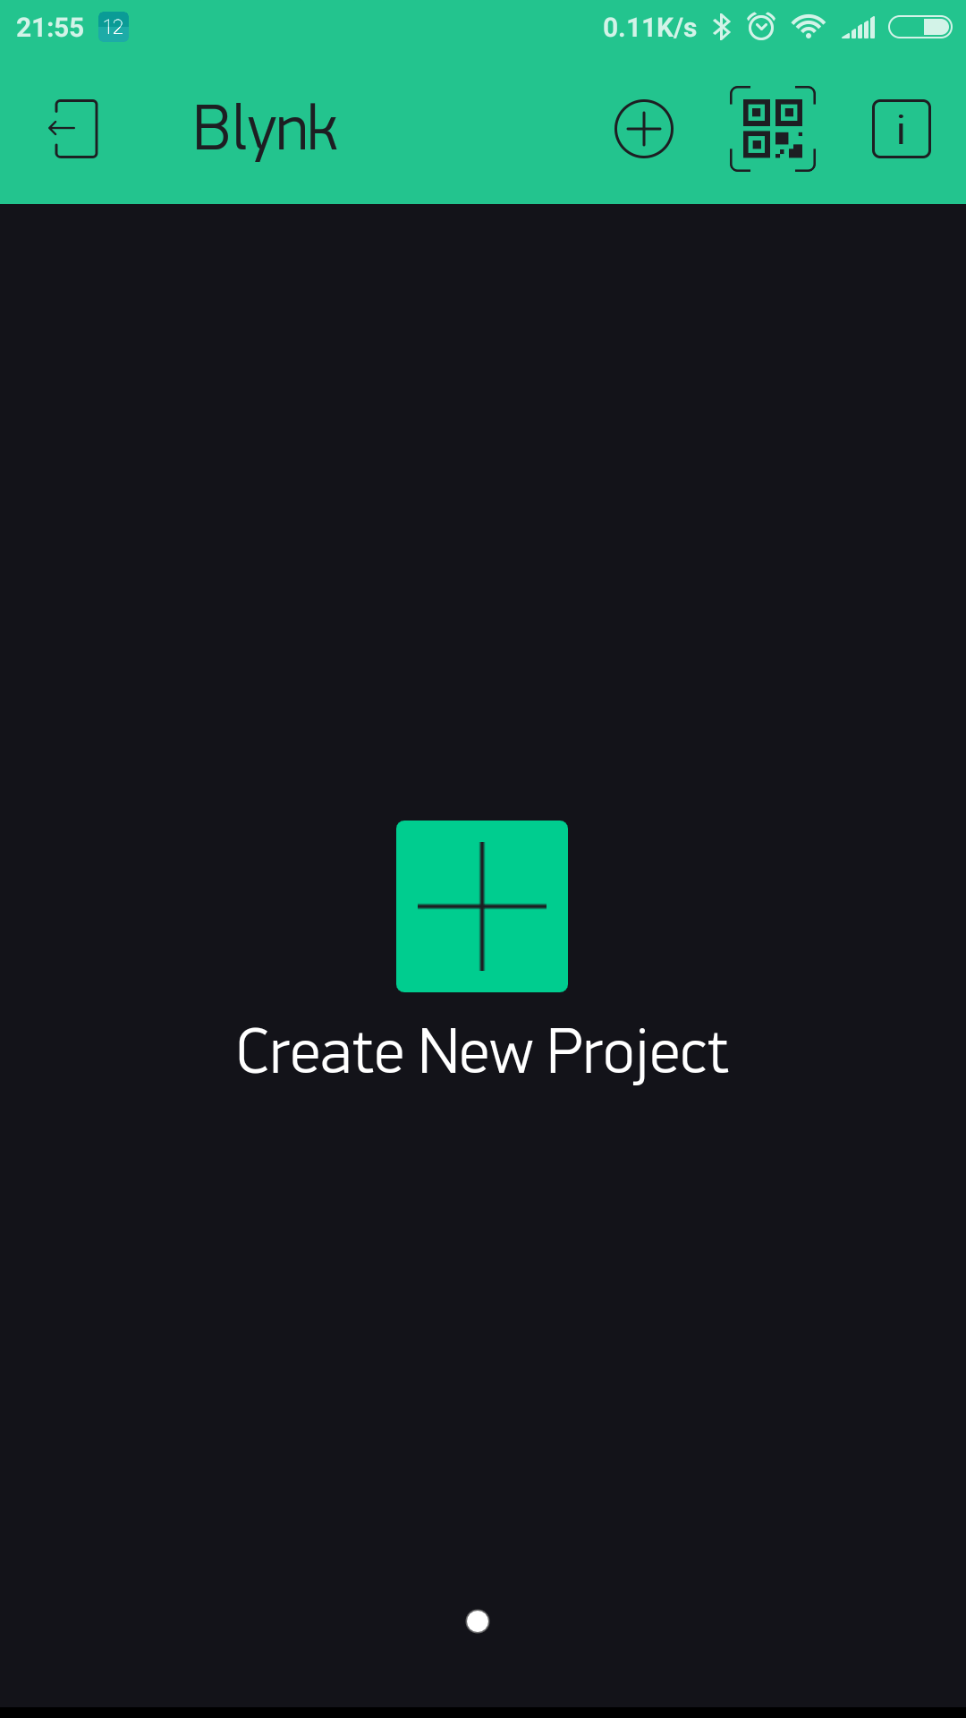

**Fig 7.4.2. Create a New Project**

**7.4.3. Choose Your Hardware {STEP 3}**

Blynk supports more than 400 boards already, including support for Arduino, Particle, and ARM mbed, TI Energia, Micro Python, Node.js, OpenWRT and many Single Board Computers.

Create a project name and choose device by ESP32 Dev Board and choose connection type by Wi-Fi.

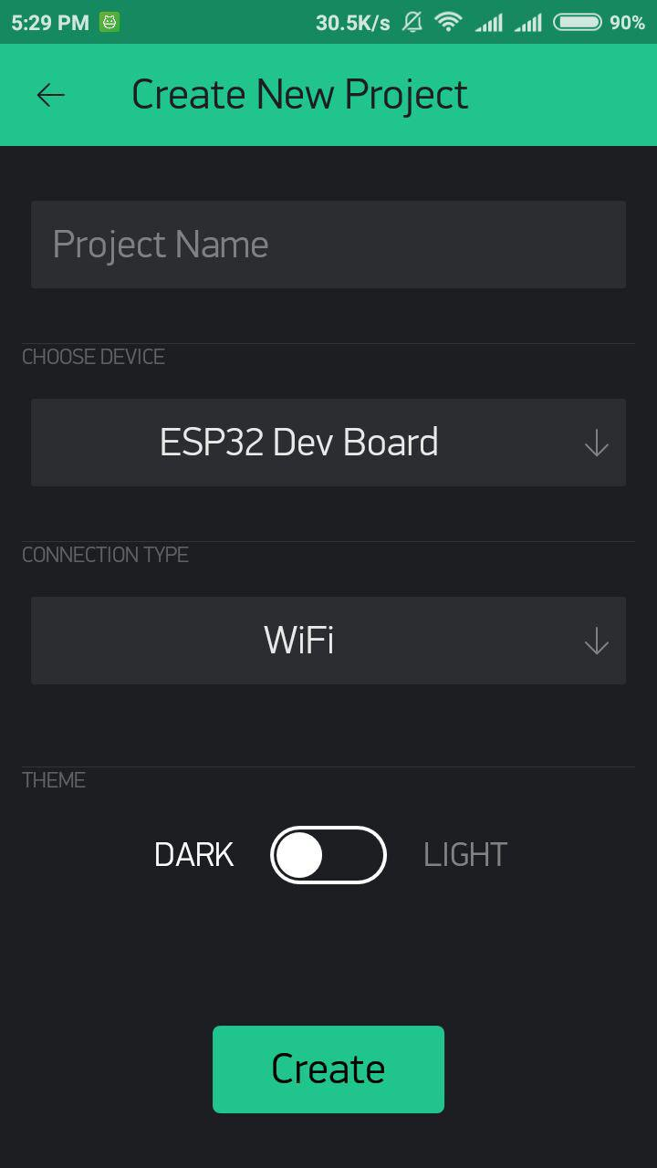

**Fig 7.4.3 Choose Your Hardware**

After press "Create" button, a window will pop up "Auth token was sent to....” You can open your email to check your authentication key.

**7.4.4. Auth Token Setting {STEP 4}**

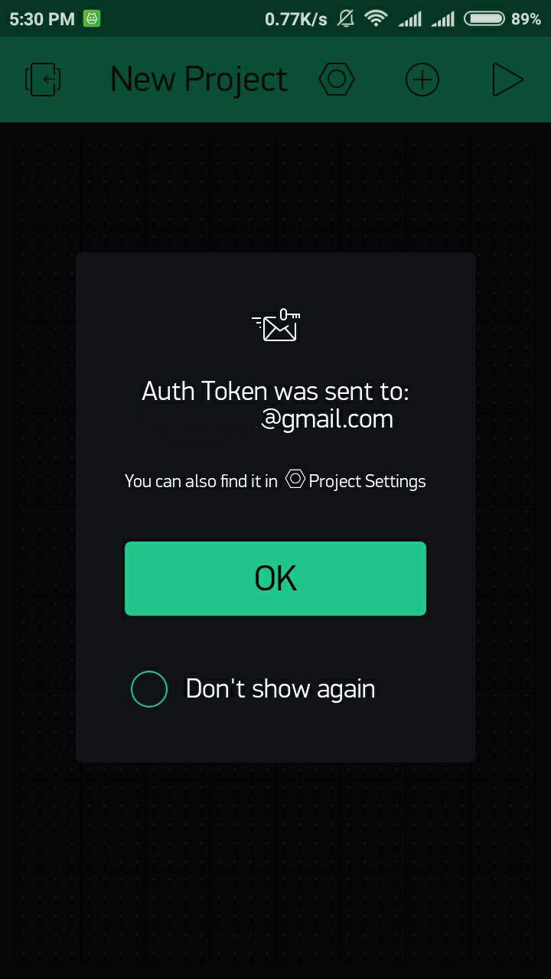Auth Token is a unique identifier which is needed to connect your hardware to your smartphone. Every new project you create will have its own Auth Token. You’ll get Auth Token automatically on your email after project creation. You can also copy it manually. Click on devices section and selected required device:

**Fig 7.4.4 Auth Token Setting**

NOTE: Don’t share your Auth Token with anyone, unless you want someone to have access to your hardware.

It’s very convenient to send it over e-mail. Press the e-mail button and the token will be sent to the e-mail address you used for registration. You can also tap on the Token line and it will be copied to the clipboard.

After press "Create" button, a window will pop up "Auth token was sent to....” You can open your email to check your authentication key.

**7.4.5. Add a Widget {STEP 5}**

Your project canvas is empty, let’s add some buttons to control our Appliances.

Tap anywhere on the canvas to open the widget box. All the available widgets are located here. Now pick a button.

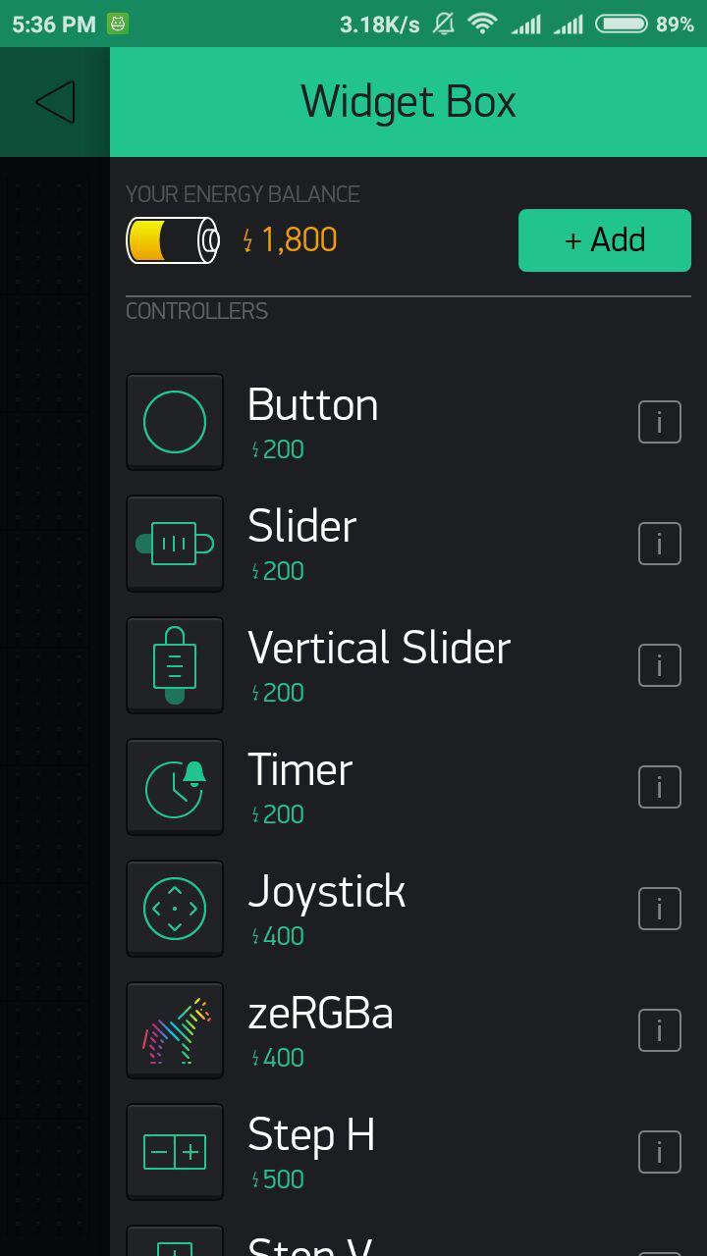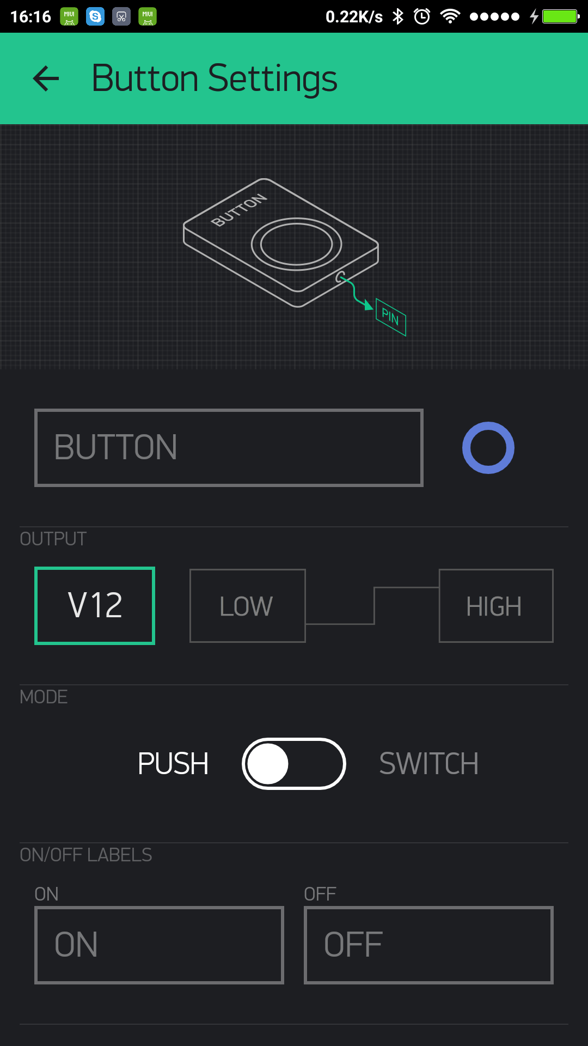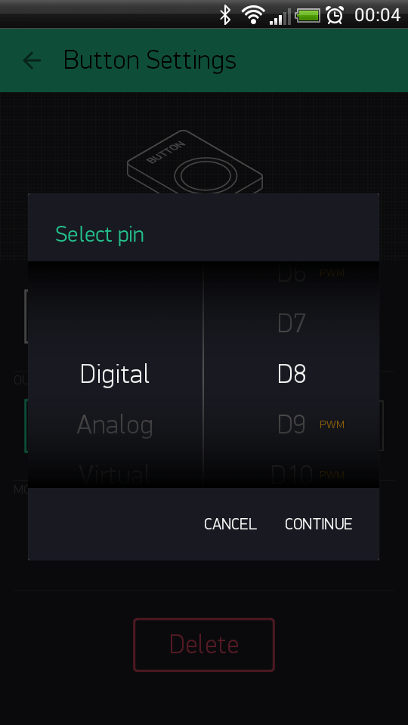

**Fig 7.4.5 Add a Widget**

**Drag-n-Drop** - Tap and hold the Widget to drag it to the new position.

**Widget Settings** - Each Widget has its own settings. Tap on the widget to get to them.

The most important parameter to set is PIN. The list of pins reflects physical pins defined by your hardware. If your LED is connected to Digital Pin 8 - then select D8 (D - stands for Digital).

**7.4.6. Run the Project {STEP 6}**

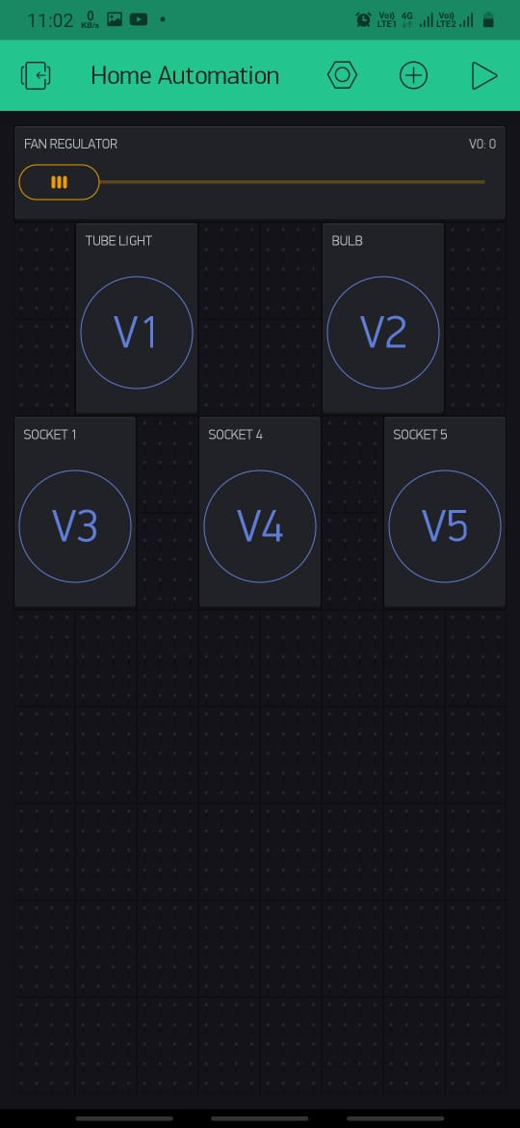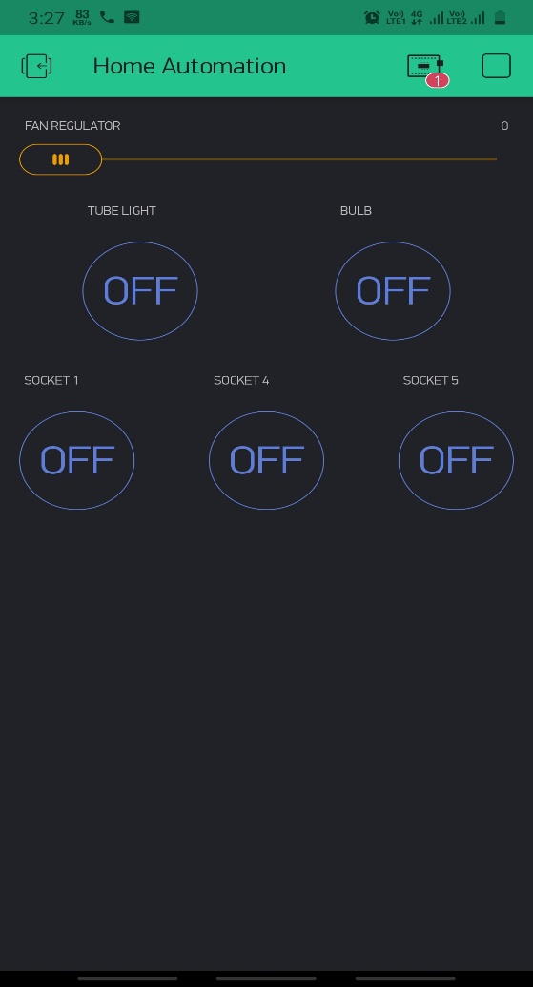When you are done with the Settings - press the PLAY button. This will switch you from EDIT mode to PLAY mode where you can interact with the hardware. While in PLAY mode, you won’t be able to drag or set up new widgets, press STOP and get back to EDIT mode.

**Fig 7.4.6 Run the Project**

**7.5 VOICE ASSISTANT MODULE**

**7.5.1. Create a Smart NORA Account**

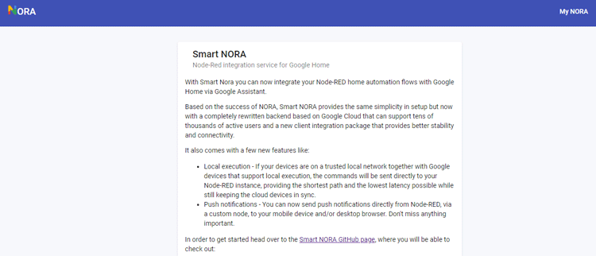To get started with NORA you have to register an account on the NORA website. So, go ahead and click on ‘Sign in with Google'. Make sure you select the same Google account as your Google Assistant.

**Fig 7.5.1 Create a Smart NORA Account**

On the next screen, it will ask you to verify the email. Verify your email address by clicking the link in the email.

**7.5.2. Creating a Flow in Node-RED**

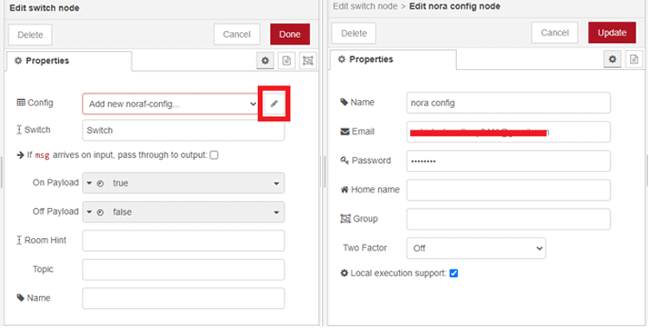

**Fig 7.51 Creating a Flow in Node-RED**

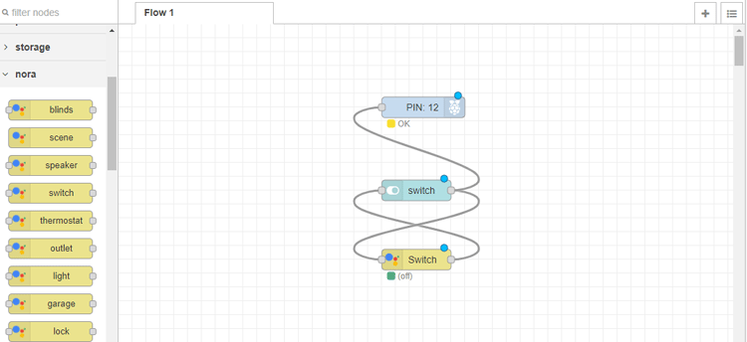The final flow will look like this:

**Fig 7.5.2 Final flow of NORA**

**7.5.3. Adding NORA to Google Assistant**

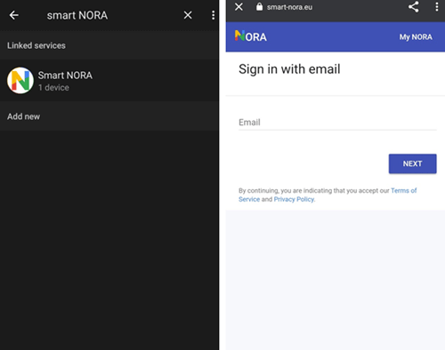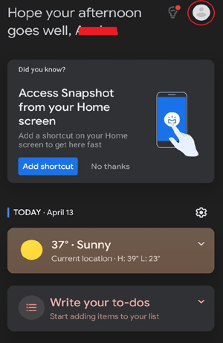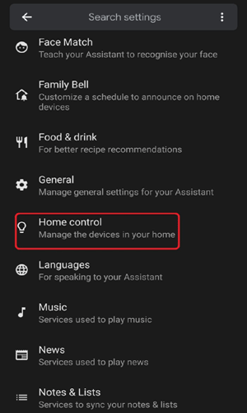In the final step, we have to add NORA to Google Assistant or Google Home devices. For that open the Google Assistant and click on the account icon in the top right corner.

**Fig 7.5.3 Adding NORA to Google HOME**

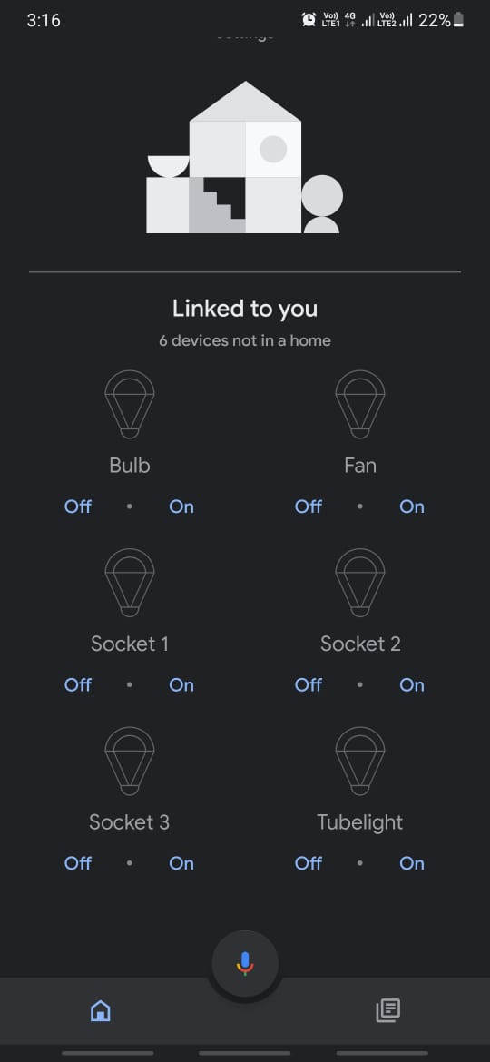

**Fig 7.5.4 Adding NORA to Google HOME**

**CHAPTER 8**

**TESTING**

**8.1 INTRODUCTION OF TESTING:**

Testing is a process of executing a program with the intent of finding an error. A good test case is one that has a high probability of finding an as-yet-undiscovered error. A successful test is one that uncovers an as-yet-undiscovered error. System testing is the stage of implementation, which is aimed at ensuring that the system works accurately and efficiently as expected before live operation commences. The software testing process commences once the program is created and the documentation and related data structures are designed. Software testing is essential for correcting errors. Software testing is the critical element of software quality assurance and represents the ultimate the review of specification design and coding.

**8.2. SOFTWARE TESTING:**

It is the process of testing the functionality and correctness of software by running it. Process of executing a program with the intent of finding an error. A good test case is one that has a high probability of finding an as yet undiscovered error, successful test is one that uncovers an as yet undiscovered error. In this project the testing is performed by running the various equipment and integrating with each other and finding all the errors and then debugging the occurred errors and correcting that errors.

**8.3. BLACK BOX TESTING:**

Applies to software systems or module, tests functionality in terms of inputs and outputs at interfaces. Test reveals if the software function is fully operational with reference to requirements specification failing this a systematic approach may be necessary. Equivalence partitioning is where the input to a program falls into a number of classes. E.g. positive numbers vs. Negative numbers. Programs normally behave the same way for each member of a class. Partitions exist for both input and output. Partitions may be discrete or overlap. Invalid data (i.e. outside the normal partitions) is one or more partitions that should be tested.

1. Black box testing is done to find incorrect or missing function

2. Interface error

3. Error in external databases

4. Performance error

5. Initialization and termination error

Black box testing is rarely exhaustive (because one doesn't test every value in an equivalence partition) and sometimes fails to reveal corruption defects caused by "weird" combination of inputs. Black box testing should not be used to try and reveal corruption defects caused, for example, by assigning a pointer to point to an object of the wrong type. Static inspection (or using a better programming language!) is preferable for this. In this testing we have tested all the requirement specifications that are required for our project, input functionality and also output functionality.

**8.4. WHITE BOX TESTING:**

Knowing the internal workings i.e., to test if all internal operations are performed according to program structures and data structures. To test if all internal components have been adequately exercised. Testing based on knowledge of structure of component (e.g. by looking at source code). Advantage is that structure of code can be used to find out how many test cases need to be performed. Knowledge of the algorithm can be used to identify the equivalence partitions. Path testing is where the tester aims to exercise every independent execution path through the component. All conditional statements tested for both true and false cases. If a unit has n control statements, there will be up to 2n possible paths through it. This demonstrates that it is much easier to test small program units than large ones. Flow graphs are a pictorial representation of the paths of control through a program. Use flow graph to design test cases that execute each path. Static tools may be used to make this easier in programs that have a complex branching structure. Tools support. Dynamic program analysers instrument a program with additional code.

**8.5. SOFTWARE TESTING STRATEGIES:**

Testing needs to be planned to be cost and time effective. Planning is setting out standards for tests. Test plans set out the context in which individual engineers can place their own work. Typical test plan contains:

* + Unit testing
  + Integration testing
  + Validation testing
  + System testing

### **8.5.1 Unit testing:**

It concentrates on each unit of the software as implemented in source code and is a white box oriented. Using the component level design description as a guide, important control paths are tested to uncover errors within the boundary of the module. In the unit testing, the step can be conducted in parallel for multiple components. In this testing we have tested all module individually for checking errors and analyzing them.

### **8.5.2 Integration testing:**

Here focus is on design and construction of the software architecture. Integration testing is a systematic technique for constructing the program structure while at the same time conducting tests to uncover errors associated with interfacing. The objective is to take unit tested components and build a program structure that has been dictated by design.

In this testing we have built (combined) all the module that are tested in unit testing and check the build module for checking errors.

### **8.5.2 Validation testing:**

In this, requirements established as part of software requirements analysis are validated against the software that has been constructed i.e., validation succeeds when software functions in a manner that can reasonably expected by the customer.

### **8.5.3 System testing:**

System testing is testing conducted on a complete integrated system to evaluate the system's compliance with its specified requirements. System testing takes, as its input, all of the integrated components that have passed integration testing. The purpose of integration testing is to detect any inconsistencies between the units that are integrated together

**8.6 PRINCIPLES OF SOFTWARE TESTING:**

Software testing is an extremely creative and challenging task. Some important principles of software testing are as given: -

* + All tests should be traceable to customer requirements.
  + Testing time and resources should be limited i.e. avoid redundant testing.
  + It is impossible to test everything.
  + Use effective resources to test.
  + Test should be planned long before testing begins i.e. after requirement phase.
  + Test for invalid and unexpected input conditions as well as valid conditions.
  + Testing should begin in “in the small” and progress towards testing “in the large”.
  + For the most effective testing should be conducted by an independent party.
  + Keep software static (without change meanwhile) during test.
  + Document test cases and test results

## **8.6 BLACK-BOX TESTING FOR Project:**

In this testing we have tested all internal operations i.e. checking all modules are working properly working by opening or running the project. And tested that modules working accordingly to program structure and data structure. The easiest way to start is by considering the project as a black box. We don’t have any idea about how it works, what is its specification.

**8.6.1Test Cases:**

Test case is a set of condition or variables under which a testing team or tester will determine whether an application or software system is working correctly or not. The test case can be broadly classified into 3 categories:

Formal Test Cases a formal written test case is a test where input is known and input is an expected output which is worked out before the test is executed.

Informal Test Cases Informal test are mainly used in scenario testing which are generally of multiple steps and not written down like formal tests.

Typical Written Test Cases Typical Written Test Case contain the test case data documented in detail.

### **Case Description:**

### **Test Case 3: Test Cases for Fan Regulator Test Case Description:**

In this test case we are going to check and validate Fan Regulator Slider module:

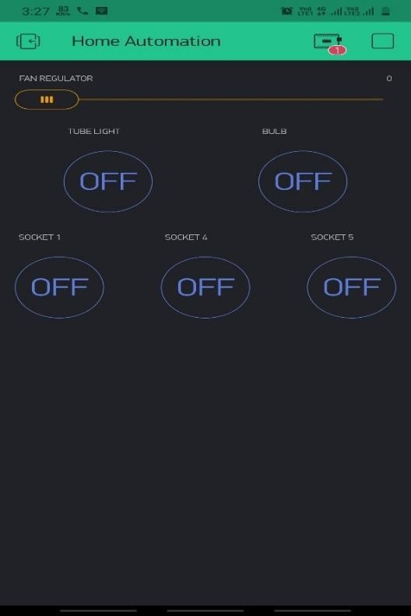

**Fig8.6.1 Test Cases for Fan Regulator Test**

### **Test Cases for Fan Regulator Slider module:**

* 1. Check if circuit is closed and all appliances are connected properly 2.Verify if dimmer/regulator are working or not using multimeter 3.Check if the slider is moving or not

1. Verify that if slider is moving towards right side the speed of fan is increasing or vice-versa
2. Verify that only those appliances should be affected those are related to the slider and rest of appliances should remain as it is

### **Test Case 3: Test Cases for Tube light button Test Case Description: -**

In this test case we are going to check and validate Tube light button module

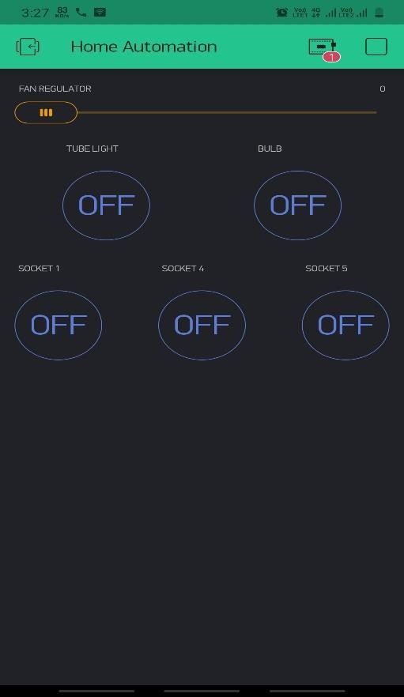

*Fig No.8.6.2* **Tube light button Test Case**

Test Cases for Tube light module:

# 1.Check if circuit is closed and all appliances are connected properly 2.Verify that tube light is working properly or not using proper equipment 3.Check if the button is working or not i.e. it is getting on / off properly

1. Verify that after pressing button once it should switch on tube light and again pressing button it should be switch off

# Verify that only those appliances should be affected those are related to the that on/off button and rest of appliances should remain as it is

### **Test Case 4: Test Cases for bulb button Test Case Description:**

In this test case we are going to check and bulb button module

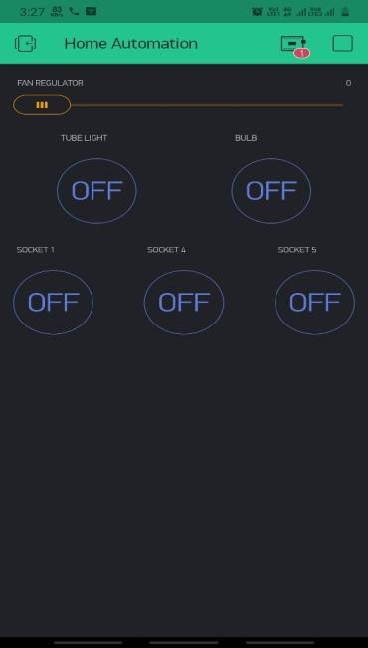

*Fig No.8.6.3* **for bulb button Test Case**

### **Test Cases for bulb button module:**

1.Check if circuit is closed and all appliances are connected properly 2.Verify that bulb is working properly or not using proper equipment 3.Check if the button is working or not i.e. it is getting on / off properly

1. Verify that after pressing button once it should switch on bulb and again pressing button it should be switch off
2. Verify that only those appliances should be affected those are related to the that on/off button and rest of appliances should remain as it is

### **Test Case 5: Test Cases for Socket button module Test Case Description:**

In this test case we are going to check and validate socket button module

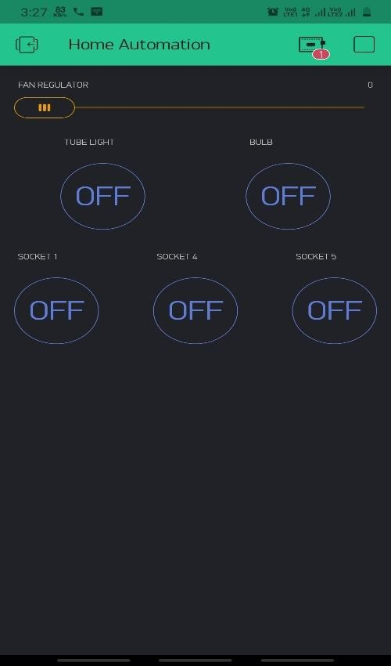

*Fig No.8.6.4* **Socket button module Test**

### **Test Cases for socket button module:**

1. Check if circuit is closed and all appliances are connected properly
2. Verify that connecting device is working properly or not using proper equipment 3.Check if the button is working or not i.e. it is getting on / off properly
3. Verify that after pressing button once it should switch on connecting and again pressing button it should be switch off
4. Verify that only those appliances should be affected those are related to the that on/off button and rest of appliances should remain as it is

### **Test Case 6: - ESP 32/ Node MCU ESP8266 Test Case Description:**

In this test case we are going to check and validate ESP 32/ Node MCU ESP8266 module

**Test case for ESP 32:**

1. Test that can be done is to power up the board via a USB cable and to check that the red LED lights up as shown in the image below.
2. This confirms that the 3.3V power from the on-board regulator is working.

### **Test Case 6: - Relays Test Case Description:**

In this test case we are going to check RELAYS

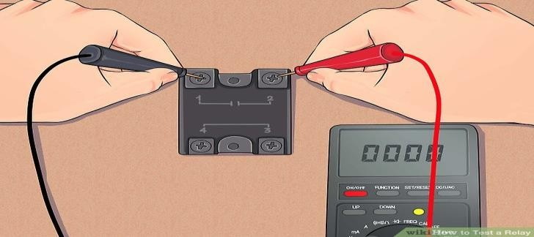

*Fig No.8.6.5* **Relays Test Case**

**Test case for RELAYS: -**

1. Check the Relay’s Coil Terminals Using a Multimeter, to check the relay whether it’s good or faulty one, we need to check the resistance of a coil.
2. In the Relay, there is a coil and that coil has some resistance, using that resistance knowledge we can find that the relay is a good one or no.

### **Test Case 7: - Breadboard Test Case Description:**

In this test case we are going to check Breadboard

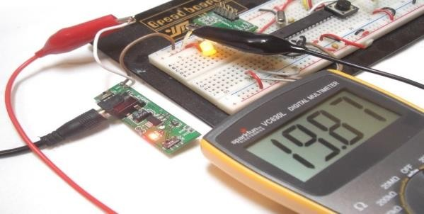

*Fig No.8.6.6* **Breadboard Test**

### **Test Case for breadboard:**

1. You test the isolation of one row from another by touching one probe to “A” and the other probe to the “A” hole in the row below.
2. The row is isolated from the one below it if the multimeter reads infinite.
3. If you question the functionality of other sections of the breadboard, repeat these tests in those places. Find the row number listed on the left side of the breadboard.
4. You test the continuity of the “+” column for a given bus by touching one of the multimeter probes to the top hole and touching the other probe to the bottom hole in the same column.
5. The multimeter will read around zero if the device under test has continuity.

### **Test Case 7: - Capacitor Test Case Description:**

In this test case we are going to check Capacitor

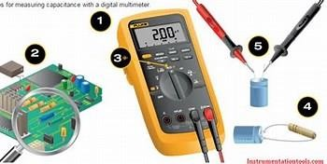

*Fig No.8.6.7* **Capacitor Test**

### **Test case for Capacitor:**

1. Make sure the capacitor is discharged: One of the main functions of a capacitor is to store power; Set the digital multimeter in a high Ohm range.
2. The ideal meter reading should be above 1000 Ohm = 1k.
3. Connect the meter leads to the capacitor terminals: For a polarized capacitor, connect the red probe to the positive terminal and the black probe to the negative terminal.
4. For a non-polarized capacitor, you can connect it either way. Note the digital resistance reading. The digital multimeter will start reading from zero and move towards infinity

It will then stop at a digital resistance value and return to the Open Line. Note the reading and check whether

**CHAPTER 9**

**CONCLUSION**

Today, Android is the world’s powerful mobile platform open-source operating system to fit easily whatever the functionality we had in our mind. This article is about wireless home automation using Android mobile helps you to implement such a fantastic system in our home at a very reasonable price using cost-effective devices. Thus, it overcomes many problems like costs, inflexibility, security etc. In addition, will provide greater advantages like it decrease our energy costs, it improves home security. In addition, it is very convenient to use and will improve the comfort of our home.

**CHAPTER 10**

**FUTURE SCOPE**

The Future scope of this project is totally bases upon sensors that are to be used to automate the home, based on human behaviour the sensor senses the actions and reactions of human beings and give the accurate solution for the need that is required.

There are many sensors compatible with ESP 32 Wroom like as follows:

1. Motion Sensors

2. Temperature Sensors

3. Light Sensors

4. Humidity Sensors

5. Sound Sensors

6. IR Sensors

7. Ultrasonic Sensors.

These mentioned sensors are used to collect data from the surrounding for the analysis and the data analysis we’ll be doing based upon the collected data is also a part of the Future Scope.

**CHAPTER 11**

**REFERENCES**

1. Sirsath N. S, Dhole P. S, Mohire N. P, Naik S. C & Ratnaparkhi N.S Department of Computer Engineering, 44, Vidyanagari,Parvati,Pune-411009,India University of Pune, “Home Automation using Cloud Network and Mobile Devices”.

2. Deepali Javale, Mohd. Mohsin, Shreerang Nandanwar “Home Automation and Security System Using Android ADK” in International Journal of Electronics Communication and Computer Technology (IJECCT) Volume 3 Issue 2 (March 2013).

3. Charith Perera, Student Member, IEEE, Arkady Zaslavsky, Member, IEEE, Peter Christen ,and Dimitrios Georgakopoulos, Member, IEEE “Context Aware Computing for The Internet of Things: A Survey”. IEEE COMMUNICATIONS SURVEYS & TUTORIAL.